16 September 2021
171-21
Supporting document 1
Safety assessment – Application A1226
Food derived from insect-protected corn line MON95379

Executive summary
Background
Application A1226 seeks approval for the sale and use of food derived from genetically modified (GM) corn line MON95379 that is protected against parasitic lepidopteran insect pests.
Protection against lepidopteran insect pests is conferred by the expression in the plant of two novel Bacillus thuringiensis crystal (Cry) proteins: Cry1B.868 encoded by the cry1B.868 gene and Cry1Da_7 encoded by the cry1Da_7 gene. These novel substances cause midgut damage specifically in lepidopteran larvae, such as fall armyworm and corn earworm larvae. While FSANZ has assessed and approved numerous B. thuringiensis Cry proteins in a variety of plant species, the cry1B.868 and cry1Da_7 genes have not previously been assessed by FSANZ.
This safety assessment addresses food safety and nutritional issues associated with the GM food. It therefore does not address:
• risks related to the environmental release of GM plants used in food production
• risks to animals that may consume feed derived from GM plants
• the safety of food derived from the non-GM (conventional) plant.
History of use
Corn is the world’s dominant cereal crop. It has a long history of safe use in the food supply, dating back thousands of years. Corn-derived products are routinely used in a large number and diverse range of foods, e.g. cornflour, starch products, breakfast cereals and high fructose corn syrup. Corn is also widely used as a livestock feed.
Molecular characterisation
The genes encoding Cry1B.868 (cry1B.868) and Cry1Da_7 (cry1Da_7) were introduced into corn line MON95379 via Agrobacterium-mediated transformation. This transformation also introduced a selectable marker cassette that was subsequently removed using the Cre/lox recombination system.
Detailed molecular analyses of corn line MON95379 indicate that a single copy of the linked cry1B.868 and cry1Da_7 expression cassettes is present at a single insertion site in the genome. There are no extraneous plasmid sequences, selectable marker cassettes, Cre recombinase, nor antibiotic resistance marker genes, present in this line.
The introduced genetic elements were shown by molecular techniques and phenotypic analyses to be stably inherited across multiple generations. The pattern of inheritance supports the conclusion that the introduced traits occur within a single locus in the MON95379 genome and are inherited in accordance with Mendelian principles.
Characterisation and safety assessment of new substances
Cry1B.868 and Cry1Da_7 are newly expressed proteins present in MON95379. They are expressed at a low level in grain (26 and 0.25 µg/g dry weight, respectively) and at a high level in leaf tissue (630 and 92 µg/g dry weight, respectively). A range of characterisation studies confirmed the identity of the plant-expressed Cry1B.868 and Cry1Da_7 and their equivalence with the corresponding protein produced in a B. thuringiensis expression system. Bioinformatic studies confirmed a lack of any significant amino acid sequence similarity to known protein toxins or allergens. Laboratory studies demonstrated the Cry1B.868 and Cry1Da_7 proteins are susceptible to the action of digestive enzymes and would be thoroughly degraded before it could be absorbed during passage through the gastrointestinal tract. The proteins are also susceptible to heat denaturation and degradation at the high temperatures typically used in food processing. Taken together, the evidence supports the conclusion that Cry1B.868 and Cry1Da_7 are not toxic or allergenic in humans.
Compositional analyses
Detailed compositional analyses were performed on MON95379. Analytes measured were proximates (protein, fat, fibre, ash, carbohydrates), amino acids, fatty acids, minerals, vitamins, anti-nutrients and secondary metabolites. Statistically significant differences were found between grain from MON95379 and the control for 18 of the 68 analytes evaluated, however differences were small and all were within the range established for existing commercial non-GM corn cultivars. Overall, the compositional data support the conclusion that there are no biologically significant differences in the levels of key constituents in grain from MON95379 compared to non-GM corn cultivars available on the market.
Conclusion
No potential public health and safety concerns have been identified in the assessment of insect-protected corn line MON95379. On the basis of the data provided in the present application, and other available information, food derived from MON95379 is considered to be as safe for human consumption as food derived from non-GM corn cultivars.
Table of contents
Executive summary 1
Index of Figures 5
Index of Tables 5
List of Abbreviations 5
1 Introduction 7
2 History of use 7
2.1 Host organism 7
2.2 Donor organisms 8
2.2.1 Bacillus thuringiensis 8
2.2.2 Other organisms 8
3 Molecular characterisation 9
3.1 Transformation Method 9
3.2 Detailed description of inserted DNA 10
3.2.1 cry1B.868 expression cassette 10
3.2.2 cry1Da_7 expression cassette 11
3.2.3 Other sequences 11
3.3 Development of the corn line from original transformation 13
3.4 Characterisation of the inserted DNA and site(s) of insertion 14
3.4.1 Identifying the number of integration site(s) 14
3.4.2 Absence of backbone and other sequences 15
3.4.3 Insert integrity and site of integration 16
3.4.4 Stability of the genetic changes in corn line MON95379 16
3.4.5 Open reading frame analysis 18
3.4.6 Conclusion 19
4 Characterisation and safety assessment of novel substances 20
4.1 Cry1B.868 20
4.1.1 Characterisation of Cry1B.868 expressed in MON95379 and equivalence to a bacterially-produced form 21
4.1.2 Expression of Cry1B.868 in MON95379 tissue 23
4.1.3 Safety of the introduced Cry1B.868 23
4.1.4 Conclusion 26
4.2 Cry1Da_7 26
4.2.1 Characterisation of Cry1Da_7 expressed in MON95379 and equivalence to a bacterially-produced form 27
4.2.2 Expression of Cry1Da_7 in MON95379 tissue 28
4.2.3 Safety of the introduced Cry1Da_7 29
4.2.4 Conclusion 31
5 Compositional analysis 31
5.1 Key Components 31
5.2 Study design 32
5.3 Analyses of key components in grain 33
5.3.1 Protein and amino acids 33
5.3.2 Total fat and fatty acids 34
5.3.3 Carbohydrates and fibre 35
5.3.4 Ash and minerals 35
5.3.5 Vitamins 36
5.3.6 Anti-nutrients and secondary metabolites 37
5.4 Conclusion 37
6 Nutritional impact 38
7 References 40
Appendix 1 44
Appendix 2 46

Index of Figures
 | Title | Page
Figure 1 | Map of the PV-ZMIR522223 transformation plasmid | 10
Figure 2 | Breeding path used in the characterisation of the MON95379 | 13
Figure 3 | Insert and flanking sequences present in MON95379 | 14
Figure 4 | Breeding path used to assess the inheritance and genetic stability of MON95379 | 17
Figure 5 | Representation of the domain architecture of the Cry1B.868 protein and similarity with derived sequences | 21
Figure 6 | N-terminal amino acid sequences of MON95379- and B. thuringiensis-derived Cry1B.868 | 22
Figure 7 | Stages of corn growth | 23
Figure 8 | Representation of the domain architecture of Cry1Da_7 and similarity with Cry1Da | 26
Figure 9 | N-terminal amino acid sequences of MON95379- and B. thuringiensis-derived Cry1Da_7 | 28

Index of Tables
 | Title | Page
Table 1 | PV-ZMIR522223-derived genetic elements present in MON95379 | 11
Table 2 | MON95379 generations used for various analyses | 13
Table 3 | Segregation results in three generations of MON95379 | 17
Table 4 | Expression of Cry1B.868 (µg/g dw) in various tissues | 23
Table 5 | Bioactivity of heat-treated Cry1B.868 (15 min) in a diet fed to insect larvae | 25
Table 6 | Bioactivity of heat-treated Cry1B.868 (30 min) in a diet fed to insect larvae | 26
Table 7 | Expression of Cry1B.868 (µg/g dw) in various tissues | 28
Table 8 | Bioactivity of heat-treated Cry1Da_7 (15 min) in a diet fed to insect larvae | 30
Table 9 | Bioactivity of heat-treated Cry1Da_7 (30 min) in a diet fed to insect larvae | 31
Table 10 | Analytes measured in the grain samples | 33
Table 11 | Comparison of protein and amino acids (% dw) | 33
Table 12 | Comparison of total fat (% dw) and fatty acids (% total fat) | 34
Table 13 | Comparison of carbohydrates by calculation and fibre (% dw) | 35
Table 14 | Comparison of ash and minerals | 36
Table 15 | Comparison of vitamins (mg/kg dw) | 36
Table 16 | Comparison of anti-nutrients (% dw) and secondary metabolites (µg/g dw) | 37
Table 17 | Summary of statistically significant compositional differences between control and MON95379 | 38

List of Abbreviations
Abbreviation | Description
ADF | acid detergent fibre
AFSI | Agriculture and Food Systems Institute
BLOSUM | BLOcks SUbstitution Matrix
bp | base pair
CI | confidence limit
COMPARE | COMprehensive Protein Allergen REsource
Cry | crystal protein
DNA | deoxyribonucleic acid
dw | dry weight
ECL | enhance chemiluminescence
ELISA | enzyme-linked immunosorbent assay
EPSPS | 5-enolpyruvyl-3-shikimatephosphate synthase
FASTA | fast alignment search tool – all
FSANZ | Food Standards Australia New Zealand
g | gram
GM | genetically modified
h | hours
HFCS | high fructose corn syrup
ILSI | International Life Sciences Institute
kDa | kilodalton
LB | left border of T-DNA
LOD | limit of detection
LOQ | limit of quantitation
min | minutes
mRNA | messenger RNA
MT | million tons
NCBI | National Centre for Biotechnology Information
NDF | neutral detergent fibre
ng | nanogram
NGS | next generation sequencing
ns | not significant
OECD | Organization for Economic Co-operation and Development
OGTR | Office of the Gene Technology Regulator
ORF | open reading frame
PCR | polymerase chain reaction
RB | right border of T-DNA
RNA | ribonucleic acid
SDS-PAGE | sodium dodecyl sulfate polyacrylamide gel electrophoresis
SE | standard error
TDF | total dietary fibre
T-DNA | transfer DNA
μg | microgram
US | United States
UTR | untranslated region

1 Introduction
FSANZ received an application from Bayer CropScience Proprietary Limited to vary Schedule 26 in the Australia New Zealand Food Standards Code (the Code). The variation is to include food from a new genetically modified (GM) corn line MON95379, with the OECD Unique Identifier MON-95379-3. This corn line is protected against parasitic lepidopteran insect pests, including fall armyworm and corn earworm.
Protection from lepidopteran insect pests is achieved with the expression of two novel crystal (Cry) proteins derived from the soil bacterium Bacillus thuringiensis: Cry1B.868 and Cry1Da_7. The Cry1B.868 protein is encoded by the cry1B.868 gene and is comprised of multiple domains from different Cry proteins from B. thuringiensis and subspecies aizawai and kurstaki (see Section 4.1). The Cry1Da_7 protein is encoded by the cry1Da_7 gene. Cry1Da_7 is a modified version of the Cry1Da protein derived from the B. thuringiensis subspecies aizawai.
Globally, many different B. thuringiensis Cry proteins are found in a variety of different GM plants (FAO 2021; ISAAA 2021). FSANZ has assessed and approved 28 applications where Cry proteins have been introduced into crops for pest protection. Crop species with Cry proteins that FSANZ has assessed and approved include corn, cotton, potato and soybean. However, A1226 is the first application to assess the Cry1B.868 and Cry1Da_7 proteins.
If approved, food derived from MON95379 corn line may enter the Australian and New Zealand food supply as imported food products.

2 History of use

2.1 Host organism
The host organism is corn (Zea mays) which is also referred to as maize. The inbred corn line LH244 was used as the parental variety for the genetic modification described in this application. This variety is a dent cultivar, which is a medium season yellow corn line that grows well in the central regions of the US corn belt. Corn line LH244 or its cross with proprietary elite inbred line HCL617, were used as the conventional control for the purposes of comparative assessment with MON95379.
Corn has been cultivated for thousands of years for human consumption and other uses (Ranum et al., 2014). It has been studied extensively due to its economic importance in many industrialised countries of the world. For more detailed information please refer to reports published by the Organisation for Economic Cooperation and Development (OECD 2002), the Grains Research and Development Corporation (GRDC 2017) and the Office of the Gene Technology Regulator (OGTR 2008).
Corn is grown worldwide as a commercial food and feed crop. It is the world’s dominant cereal crop (2020/21 = 1,125 MT) ahead of wheat (776 MT) and rice (505 MT) (USDA 2021). The US and China are the largest producers and in 2020/21 production reached 360 and 261 MT, respectively. Corn is not a major crop in Australia or New Zealand, and in 2019, production was approximately 0.327 and 0.196 MT, respectively (FAOSTAT 2019). Around 92% of all corn planted in the US is GM, while in Canada the estimate of GM corn is ~80% of total corn. GM corn is not grown commercially in Australia or New Zealand.
Australia and New Zealand supplement their limited domestic production of corn by importing corn grain and corn-based products. These imports are used widely in processed foods. Imports to Australia and New Zealand in 2019 included approximately 12,556 and 1,559 tonnes, respectively, of corn flour and 1,180 and 1,351 tonnes, respectively, of corn oil (FAOSTAT 2019). Neither Australia nor New Zealand currently produce fructose, either crystalline or as high fructose corn syrup (HFCS).
Corn has a long history of safe use as food for human consumption, although the majority of grain and forage derived from corn is used as animal feed (Loy and Lundy, 2019; OECD 2002). Human food products include corn starch, flour, meal, oil and HFCS. Corn starch is used in dessert mixes and canned foods in Australia and New Zealand. HFCS is used in breakfast cereals, baking products, corn chips and extruded confectionary.

2.2 Donor organisms

2.2.1 Bacillus thuringiensis
The DNA sequences encoding the Cry1B.868 and Cry1Da_7 proteins are derived from B. thuringiensis and its subspecies aizawai and kurstaki (Palma et al., 2014; Sanahuja et al., 2011). The gram-positive bacterium B. thuringiensis is not considered pathogenic to humans, although B. thuringiensis and the closely related B. cereus have been co-isolated from foods associated with causing diarrhoea (WHO 1999; Raymond and Federici, 2017). Both bacteria contain genes for enterotoxins; however, it is unlikely B. thuringiensis and its subspecies or strains are causal agents of food-induced diarrhoea (Raymond and Federici, 2017).
The presence of B. thuringiensis in foods is not considered unusual. B. thuringiensis and its subspecies are ubiquitous in the environment (naturally found in soil) and specific strains have a long history of safe use in food. Various strains have been utilised as commercial microbial insecticides in agriculture and forestry since 1938 in France and 1961 in the US (Nexter et al., 2002; CERA 2011). There are reported to be approximately 180 biopesticide products registered in the US, 276 in China, 120 in the European Union, 43 in Australia and 11 in New Zealand, with high usage in forestry and the organic farming industry (APVMA 2021; ACVM 2021; Koch et al., 2015; Huang et al., 2007; EPA 1998).
B. thuringiensis is subdivided into more than 70 subspecies, and the most widely used isolate in agriculture and forestry is subspecies kurstaki (Federici and Siegel, 2008). B. thuringiensis biopesticide products containing the aizawai and kurstaki subspecies have been registered with the Australian Pesticides and Veterinary Medicines Authority (APVMA) in Australia and under the Agricultural Compounds and Veterinary Medicines Act 1997, administered by the Ministry for Primary Industries in New Zealand (APVMA 2021; ACVM 2021).

2.2.2 Other organisms
Genetic elements from several other organisms have been used in the genetic modification of MON95379 (refer to Table 1). These genetic elements are non-coding sequences and are used to regulate the expression of cry1B.868 and cry1Da_7 genes.

3 Molecular characterisation
Molecular characterisation is necessary to provide an understanding of the genetic material introduced into the host genome and helps to frame the subsequent parts of the safety assessment. The molecular characterisation addresses three main aspects:
- the transformation method together with a detailed description of the DNA sequences introduced to the host genome
- a characterisation of the inserted DNA, including any rearrangements that may have occurred as a consequence of the transformation
- the genetic stability of the inserted DNA and any accompanying expressed traits.

3.1 Transformation method
In order to create the MON95379 corn line, the inbred LH244 corn line was transformed using the PV-ZMIR522223 plasmid (Figure 1). A subsequent step, involving the Cre/lox recombination system in an intermediary line, removed the cp4 epsps selectable marker. The methodology is outlined in the flowchart in Appendix 1 and summarised below.
The transformation method involved infection of immature LH244 embryos excised from a post-pollinated corn ear with Agrobacterium tumefaciens containing the PV-ZMIR522223 plasmid (Sidorov and Duncan, 2009). Immature embryos were then placed on selective media containing glyphosate and carbenicillin. Glyphosate inhibits the grown of untransformed plant cells, while carbenicillin suppresses the growth of excess Agrobacterium. Once the transformed embryos developed into calluses, the calluses were placed on media to encourage shoot and root development. Rooted plants (R0) with normal phenotypes were transferred to soil and self-pollinated to produce R1 seed. PCR screening and Southern blot analysis was then used to identify R1 plants carrying only the transfer DNA (T-DNA), allowing selection of plants that do not contain the antibiotic resistance gene located on the vector backbone (Figure 1). Identified homozygous positive R1 plant were self-pollinated, giving rise to R2 seed.
In a subsequent step, selected R2 plants were crossed with a corn line expressing Cre recombinase protein, which was developed separately with the plasmid vector PV-ZMOO513642 (Appendix 2). R2 plants contain the cp4 epsps expression cassette, which is part of the T-DNA inserted during transformation and is flanked by loxP sites (Figure 1). The Cre/lox recombination system allows the site-specific recombination of two loxP sites (Gilbertson, 2003; Zhang et al., 2003). The introduction of Cre recombinase in the R2 x Cre recombinase expressing line cross enabled the removal of the cp4 epsps expression cassette in the F1 generation. The cre gene and associated PV-ZMOO513642 sequences were segregated away by conventional breeding. Progeny were screened for the absence of the cp4 epsps expression cassette, the cre gene and other PV-ZMOO513642 sequences.
Subsequent generations were further screened using standard molecular biology techniques. Plants with the intended insertion and no unintended DNA sequences were selected, i.e. only containing the cry1B.868 and cry1Da_7 expression cassettes. Following the evaluation of insert integrity, trait efficacy, phenotypic characteristics and agronomic performance, corn line MON95379 was selected.
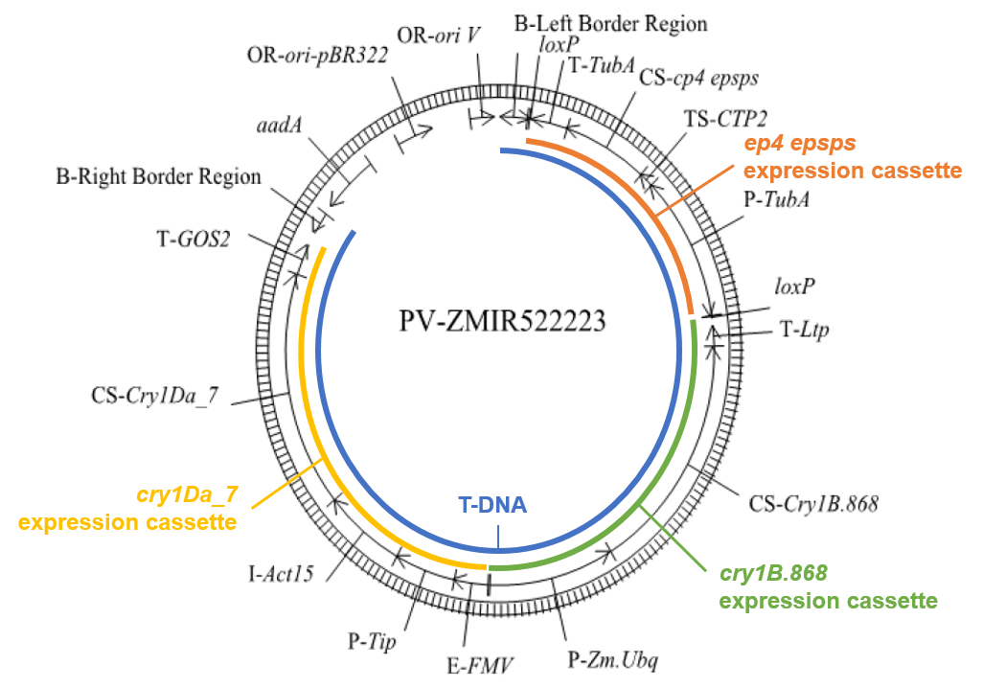
Figure 1. Map of the PV-ZMIR522223 transformation plasmid. The T-DNA (blue) contains the cp4 epsps (orange), cry1B.868 (green) and cry1Da_7 (yellow) expression cassettes. The vector backbone contains two origins of replication (ori pBR322, ori V) and the aadA antibiotic resistance gene. The vector backbone is not incorporated into the plant during transformation but is required for preparing the plasmid, passaging through standard laboratory Escherichia coli (E. coli) and into the Agrobacterium.

3.2 Detailed description of inserted DNA
The transformation process results in corn line MON95379, which contains inserted DNA sequences from the PV-ZMIR522223 plasmid. These sequences are the cry1B.868 and cry1Da_7 expression cassettes. The cp4 epsps expression cassette is part of the originally inserted T-DNA (adjacent to the left boarder (LB) region), but it was removed using the Cre/lox recombination system and is not present in MON95379 (Table 1).
The cp4 epsps gene from Agrobacterium sp. strain CP4 confers tolerance to the herbicide glyphosate, which was used to select transformed plant cells (Section 3.1). The cp4 epsps coding sequence is under the control of a promoter, 5’ untranslated region (UTR), intron and 3’UTR sequences from the tubulin (TubA) gene family from Oryza sativa (rice). Targeting sequence CTP2 of the ShkG gene from Arabidopsis thaliana directs the transport of the CP4 EPSPS protein to chloroplasts. The cp4 epsps expression cassette is removed from an intermediary line based on flanking loxP sites. These loxP sites allowed the cassette to be excised by the Cre recombinase (see Section 3.1).

3.2.1 cry1B.868 expression cassette
The cry1B.868 coding sequence is a compilation of the coding sequence of domains I and II from Cry1Be, domain II from Cry1Ca, and the C-terminal domain from Cry1Ab. These coding sequences derive from B. thuringiensis and subspecies aizawai and kurstaki. Expression of cry1B.868 is under the control of the promoter, 5’UTR and intron sequences of the ubiquitin (Ubq) gene from Zea mays subspecies Mexicana (Mexican teosinte) and the 3’UTR sequence of the Lipid Transfer Protein-like gene (LTP) from Oryza sativa (rice) that directs polyadenylation of mRNA.

3.2.2 cry1Da_7 expression cassette
The cry1Da_7 coding sequence is the codon optimised and modified version of cry1Da from B. thuringiensis subspecies aizawai. Expression of cry1Da_7 is under the control of the promoter and 5’ UTR of the tonoplast membrane integral protein (Tip) gene from Setaria italica (foxtail millet). cry1Da_7 is also regulated by the enhancer (E) of the 35S RNA of Figwort mosaic virus (FMV) and intron and flanking UTR sequence of the Actin 15 (Act 15) gene from Oryza sativa (rice). Downstream of the coding sequence is the 3' UTR sequence of the GOS2 gene from Oryza sativa that directs polyadenylation of mRNA.

3.2.3 Other sequences
There are intervening sequences present in the inserted DNA as outlined in Table 1. These sequences assist with cloning, mapping and sequence analysis.
Table 1: PV-ZMIR522223-derived genetic elements present in MON95379
Genetic element | Relative position | Size (bp) | Source | Description, Function & Reference | Present in MON95379
LB¹ region | 1-442 | 442 | Agrobacterium tumefaciens | LB sequence used to transfer the T-DNA region into the host genome (Barker et al., 1983) | Yes^{rl}
Intervening sequence | 443-513 | 71 | Synthetic |  | Yes
loxP | 478-511 | 34 | Bacteriophage P1 | Cre recombinase recognition site (Dale and Ow, 1990) | No*
Intervening sequence | 512-517 | 6 | Synthetic |  | No
cp4 epsps expression cassette
T²-TubA | 518-1099 | 582 | Oryza sativa | 3’UTR sequence from the  OsTubA gene (Jeon et al., 2000) | No
Intervening sequence | 1100-1106 | 7 | Synthetic |  | No
CS³-cp4 epsps | 1107-2474 | 1108 | Agrobacterium sp. strain CP4 | Coding sequence of the aroA gene for the CP4 EPSPS protein that provides tolerance to glyphosate (Barry et al., 2001) | No
TS⁴-CTP2 | 2475-2702 | 228 | Arabidopsis thaliana | Coding sequence of a transit peptide from the ShkG gene that directs the EPSPS protein to the chloroplasts (Herrmann, 1995; Klee et al., 1987) | No
Intervening sequence | 2703-2706 | 4 | Synthetic |  | No
P⁵-TubA | 2707-4887 | 2181 | Oryza sativa | Promoter, 5' UTR and intron sequences of the OsTubA gene family encoding  α-tubulin that directs transcription in plant cells (Jeon et al., 2000) | No
Intervening sequence | 4888-4893 | 6 | Synthetic |  | No*
loxP | 4894-4927 | 34 | Bacteriophage P1 | Cre recombinase recognition site (Dale and Ow, 1990) | Yes
Intervening sequence | 4928-5038 | 111 | Synthetic |  | Yes
cry1B.868 expression cassette
T-Ltp | 5039-5338 | 300 | Oryza sativa | 3’UTR sequence of the ltp gene that directs polyadenylation of mRNA (Hunt, 1994) | Yes
Intervening Sequence | 5339-5347 | 9 | Synthetic |  | Yes
CS-Cry1B.868 | 5348-8947 | 3600 | Bacillus thuringiensis | Coding sequence of the cry1B.868 gene that provides protection against lepidopteran insect pests (Wang et al., 2019). | Yes
Intervening Sequence | 8948-8973 | 26 | Synthetic |  | Yes
P-Zm.Ubq | 8974-10981 | 2008 | Zea mays subspecies Mexicana | Promoter, 5' UTR and first intron sequences of the Ubq gene that directs transcription in plant cells (Cornejo et al., 1993). | Yes
Intervening Sequence | 10982-11008 | 27 | Synthetic |  | Yes
cry1Da_7 expression cassette
E⁶-FMV | 11009-11545 | 537 | Figwort mosaic virus | Enhancer sequence of the 35S RNA of that enhances transcription in most plant cells (Rogers, 2000; Richins et al., 1987). | Yes
Intervening Sequence | 11546-11556 | 11 | Synthetic |  | Yes
P-Tip | 11557-12537 | 981 | Setaria italica | Promoter and 5' UTR sequences of the Tip gene that directs transcription (Hernandez-Garcia and Finer, 2014). | Yes
Intervening Sequence | 12538-12545 | 8 | Synthetic |  | Yes
I⁷-Act15 | 12546-13838 | 1293 | Oryza sativa | Intron and flanking UTR sequence of the Act 15 involved in regulating gene expression (Rose, 2008). | Yes
Intervening Sequence | 13839-13856 | 18 | Synthetic |  | Yes
CS-Cry1Da_7 | 13857-17357 | 3501 | Bacillus thuringiensis | Coding sequence of the cry1Da_7 gene that provides protection against lepidopteran insect pests (Wang et al., 2019). | Yes
Intervening Sequence | 17358-17373 | 16 | Synthetic |  | Yes
T-GOS2 | 17374-17841 | 468 | Oryza sativa | 3' UTR sequence from the GOS2 gene that directs polyadenylation of mRNA (Hunt, 1994). | Yes
Intervening Sequence | 17842-18045 | 204 | Synthetic |  | Yes
RB⁸ Region | 18046-18376 | 331 | Agrobacterium tumefaciens | RB sequence used to transfer the T-DNA region into the host genome (Barker et al., 1983) | No
^{rl} Truncation of LB region in MON95379 compared to PV-ZMIR522223.
* Bases 478 through 4893 of the PV-ZMIR522223 T-DNA was excised from an intermediary line in the development of MON95379. This removed DNA sequences in the selectable marker cassette (T-TubA, TS-CTP2, CS-cp4 epsps, and P-TubA) and one loxP site. One 34 bp loxP site remained in MON95379 (bases 4894-4927).
1. Left Border, 2. Terminator Sequence, 3. Coding Sequence, 4. Target Sequence, 5. Promoter, 6. Enhancer, 7. Intron, 8. Right Border

3.3 Development of the corn line from original transformation
A breeding programme was undertaken for the purposes of:
- obtaining generations suitable for analysing the characteristics of MON95379
- ensuring that the MON95379 event is incorporated into elite lines for commercialisation.

The breeding path from the original transformation (R0) and the specific generations of plants used in the characterisation of MON95379 is shown in Figure 2. Table 2 indicates the analysis, generation and controls used in the characterisation of MON95379.
Designates self-pollination
¹ Generations used to confirm insert stability
² Generation used for molecular characterisation
³ Generation used for commercial development of MON95379
⁴ Generation screened for plants lacking the cre gene. Only plants lacking cre were self-pollinated to create F3 plants lacking cre.
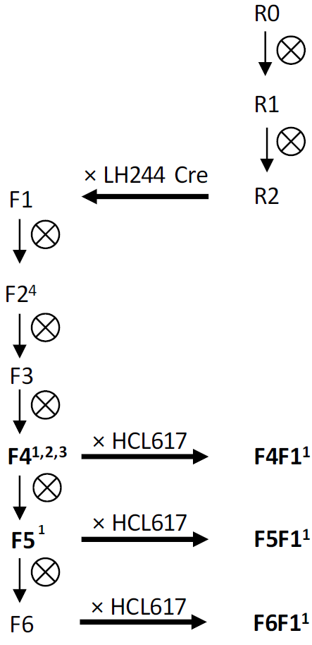
Figure 2. Breeding path used in the characterisation of the MON95379. Bolded text indicates generations used to confirm insert stability and molecular characterisation.
Table 2: MON95379 generations used for various analyses
Analysis | Section | Generation(s) used | Comparators
Number of integration sites | Section 3.4.1 | F4 | LH224
Absence of backbone and other sequences | Section 3.4.2 | F4 | LH224
Insert integrity and site of integration | Section 3.4.3 | F4 | LH224
Genetic stability | Section 3.4.4.1 | F4, F5, F4F1, F5F1, F6F1 | LH244, LH244 x HCL617
Mendelian inheritance | Section 3.4.4.2 | F4F2, F4F3, F4F4 | N/A
Expression of phenotype over several generations | Section 3.4.4.2 | F4, F4F1, F5, F5F1, and F6F1 | LH244 x HCL617
Compositional analysis | Section 5 | F5F1 | LH244 x HCL617

3.4 Characterisation of the inserted DNA and site(s) of insertion
A range of analyses were undertaken to characterise the genetic modification in MON95379. These analyses focused on the nature and stability of the insertion and whether any unintended re-arrangements or products may have occurred as a consequence of the transformation procedure.

3.4.1 Identifying the number of integration site(s)
Next-generation sequencing (NGS) was performed on seed-derived genomic DNA from MON95379 (F4) and the parental LH244 control. Additionally, plasmid DNA served as a reference control for sequencing and a transformation plasmid spike was sequenced to assess the sensitivity of the NGS. Short sequence reads (~150 bp) were prepared and sequenced. Sufficient sequence fragments were obtained to cover the entire genomes of MON95379 and the LH244 control, with a depth of coverage ≥75x and an adequate level of sensitivity.
Comparison of the sequence between MON95379 and the LH244 control detected only two unique insert-flank junction sites and showed that a single intact copy of the intended DNA was integrated into the genome of MON95379 (Figure 3). As expected, no junctions were detected in the LH244 control.
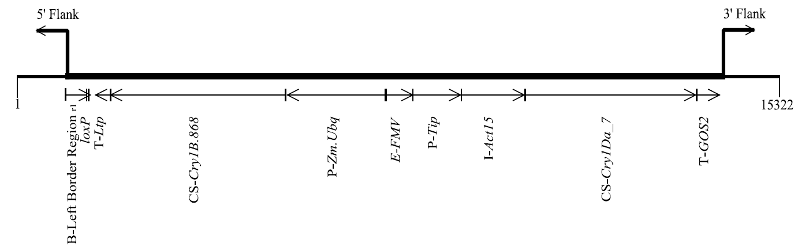
Figure 3. Insert and flanking sequences present in MON95379. ^{rl} Truncation of Left Boarder region in MON95379 compared to PV-ZMIR522223.

3.4.2 Absence of backbone and other sequences
NGS reads from MON95379 (F4) and the PV-ZMIR52223 transformation plasmid were aligned. No sequence reads mapped to the selectable marker cassette (T-TubA, TS-CTP2, CS-cp4 epsps, and P-TubA), confirming its removal using the Cre/lox recombination system. Furthermore, a single loxP site remained in the MON95379 inserted DNA, the left boarder region of the T-DNA was truncated and the right boarder region was absent (Figure 3).
No reads were detected for the backbone sequences aadA and OR-ori V, with a single pair of reads aligning with the OR-ori-pBR322 sequence (see Figure 1). This low-level detection does not indicate the presence of backbone sequence in MON95379 but is considered background noise, e.g. due to the presence of environmental bacteria found in the genomic DNA prepared for NGS (Wally et al., 2019; Zastrow-Hayes et al., 2015). The results of this alignment confirmed there was no integration of backbone sequences into MON95379, including any antibiotic resistance genes.
The LH244 control contained sequence reads that mapped to the T-DNA promoter element zm.Ubq of the PV-ZMIR522223 plasmid. However, alignments were due to the capture and sequencing of endogenous sequences from corn that are homologous to the zm.Ubq of the PV-ZMIR522223 plasmid and present in the MON95379 inserted DNA (Figure 3). No junctions between plasmid DNA and genomic DNA were identified in the LH244 control. Additionally, both MON95379 and the LH244 control had similar mapping signatures of the zm.Ubq sequence. These results indicate that the reads were identifying endogenous sequences in the LH244 control and not indicative of any additional T-DNA insertion in MON95379.
During the breeding process, the R2 generation was crossed with a corn line expressing Cre recombinase protein (Figure 2). This corn line was generated using the PV-ZMOO513642 plasmid (Appendix 2). Subsequent generations were screened for the absence of the Cre gene and other PV-ZMOO513642 sequences. To confirm their absence in MON95379 (F4) the applicant mapped sequence reads from F4 to the PV-ZMOO513642 plasmid sequence. As a control, the PV-ZMOO513642 plasmid sequence was also aligned to the LH244 control sequence reads.
The results showed that a number of reads aligned to the LB region, a small number of reads mapped to the promoter element Ract1, and a single pair of reads aligned with the OR-ori-pBR322 sequence. No other reads were detected, as well as no junction sites, i.e. between the PV-ZMOO513642 T-DNA and MON95379 genome. The detection of the LB region is expected, since PV-ZMOO513642 and PV-ZMIR522223 share the same LB region sequence and PV-MIR22223’s LB region is present in MON95379 (Figure 3). Reads mapping to the promoter element Ract1 is not unique to MON95379 but also the control, indicating a homologous sequence being present in the LH244 background and not the presence of a PV-ZMOO513642 sequence in MON95379. The low-level detection of OR-ori-pBR322 in MON95379 in this alignment is considered background noise and hence not meaningful. These results indicate that MON95379 (F4) and subsequent generations do not contain the cre gene and other sequences from the PV-ZMOO513642 plasmid.

3.4.3 Insert integrity and site of integration
Locus-specific PCR and DNA sequence analysis of seed-derived DNA from MON95379 showed that a single copy of the DNA was integrated into the host genome and the organisation of the insert is as expected. No deletions, insertions, mutations or rearrangements of the expression cassettes were detected when the MON95379 sequence was aligned with the T-DNA of the plasmid sequence. As expected, the selectable marker cassette (T-TubA, TS-CTP2, CS-cp4 epsps, and P-TubA) and one loxP site were absent. The right border (RB) region of the inserted T-DNA was also absent and there was some truncation of the LB region, but this would not affect the expression of the cry1B.868 and cry1Da_7 genes. These results were fully consistent with the NGS dataset.
PCR and DNA sequencing of LH244 genomic DNA and the 5’ and 3’ insert-flank DNA junctions of the MON95379 insert identified the site of integration. By comparing the LH224 and MON95379 sequences the analysis indicated a 160 base deletion of corn genomic DNA during T-DNA integration. Changes such as these are common during plant transformation (Anderson et al., 2016) and would not affect the expression of the cry1B.868 and cry1Da_7 genes.

3.4.4 Stability of the genetic changes in corn line MON95379
The concept of stability encompasses both the genetic and phenotypic stability of the introduced trait over a number of generations. Genetic stability refers to maintenance of the modification (as produced in the initial transformation events) over successive generations. Phenotypic stability refers to the expressed trait remaining unchanged over successive generations.

3.4.4.1 Genetic stability
NGS was used to show inheritance and genetic stability of the inserted DNA in MON95379. Sequences of seed-derived DNA from five generations of MON95379 (F4, F5, F4F1, F5F1, F6F1) were mapped to the PV-ZMIR522223 plasmid. Control genomic DNA was isolated from (1) the non-GM parental line LH244 with similar background genetics to the F4 and F5 generations and (2) the non-GM hybrid line LH244 × HCL617 with similar background genetics to the F4F1, F5F1 and F6F1 hybrids. The mapping confirmed a single intact copy of the intended DNA was integrated into the genomes of F4, F5, F4F1, F5F1 and F6F1.
Locus-specific PCR and DNA sequence analysis directly compared the DNA insert and the adjacent flanking DNA between all generations. This analysis showed the presence of the same two insert-flank junction sequences as described in Section 3.4.1. No other junction sequences were present. The consistency of these results across all generations tested demonstrates that the single inserted DNA is stably maintained in MON95379.

3.4.4.2 Phenotypic stability
Mendelian inheritance
Since the inserted DNA resides at a single locus within the MON95379 genome, it would be expected to be inherited according to Mendelian principles. Chi-square (Χ²) analysis was undertaken over three generations (as outlined in Figure 4) to confirm the segregation and stability of the inserted DNA in MON95379.
The inheritance pattern of the inserted DNA in MON95379 was assessed in F4F2, F4F3 and F4F4 generations by a Real Time TaqMan® PCR assay. This assay measured the incorporation of florescence signal into a PCR-amplified target sequence, which was designed to identify the presence of the inserted DNA in MON95379.
According to Mendelian inheritance principles the expected segregation ratio in all generations was 1:2:1. The X² critical value to reject the hypothesis of this ratio at a 5% level of significance was 5.99 (Strickberger 1976). As the X² values calculated from these experiments were < 5.99, the results showed there were no significant differences between the observed and expected segregation ratios in any of the generations (Table 3). These data support the conclusion that the inserted DNA is present at a single locus in MON95379 and was inherited predictably in subsequent generations according to Mendelian inheritance principles.
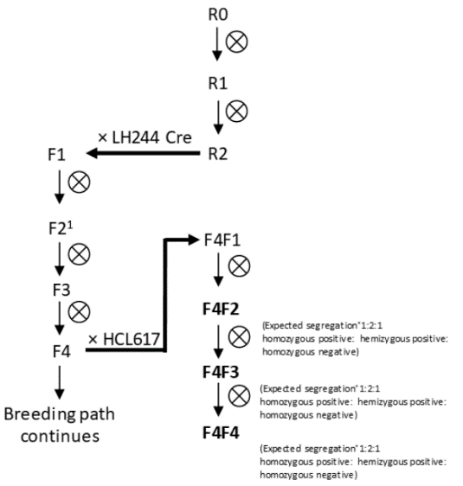
Table 3: Segregation results in three generations of MON95379
Designates self-pollination
¹ Only plants lacking cre were self-pollinated to create F3 plants lacking cre.
Figure 4. Breeding path used to assess the inheritance and genetic stability of MON95379. F4 MON95379 was crossed with the proprietary elite inbred line HCL617 to produce a F4F1 hemizygous seed. Self-crossing this line is expected to segregate at a 1:2:1 ratio (homozygous positive: hemizygous positive: homozygous negative). Continual self-crossing of hemizygous progeny is expected to result in the same ratios. Bolded text indicates generations whose segregation data was used in the X² analysis.

Generation | Expected segregation ratio | Observed number of plants  (expected number) |  |  |  | Statistical analysis
 |  | Homozygous Positive | Hemizygous positive | Homozygous Negative | Total | X² | P value
F4F2 | 1:2:1 | 60  (50) | 85  (100) | 55  (50) | 200 | 4.75 | 0.093
F4F3 | 1:2:1 | 62  (61.75) | 125  (123.5) | 60  (61.75) | 247 | 0.07 | 0.966
F4F4 | 1:2:1 | 74  (61.5) | 109  (123) | 63  (61.5) | 246 | 4.17 | 0.124
Expression of phenotype over several generations
The expression stability of Cry1B.868 and Cry1Da_7 proteins over five generations was examined. Western blot analysis was conducted on seed tissue from generations F4, F4F1, F5, F5F1 and F6F1 of MON95379 (Figure 2). Corn line LH244 × HCL617 was used as the negative control and B. thuringiensis-produced Cry1B.868 and Cry1Da_7 proteins (see Section 4.1.1, 4.2.1) were used as positive controls. Both proteins migrated similarly to the positive controls and were present in all five breeding generations. These data support the conclusion that Cry1B.868 and Cry1Da_7 proteins are stably expressed over several generations.

3.4.5 Open reading frame analysis
An in silico analysis of the flanking regions was undertaken to identify whether any novel ORFs had been created in MON95379 as a result of T-DNA insertion. Sequences spanning the 5’ and 3’ insert-flank junctions of the MON95379 were translated using from stop codon to stop codon (TGA, TAG, TAA) in all six reading frames. A total of 12 ORFs that corresponded to putative peptides of eight amino acids or greater in length were investigated further to determine whether their amino acid sequence showed similarity with known allergen and toxin peptide sequences in established databases.
In addition to the junction regions, the entire MON95379 insert DNA was translated in silico in all six reading frames. The resultant amino acid sequences cover any putative peptides present in the entire inserted DNA. These were used as query sequences in homology searches for known allergens and toxins in established databases.
These analyses are theoretical only as there is no reason to expect that any of the identified ORFs or putative peptides would, in fact, be expressed.

3.4.5.1 Bioinformatic analysis for potential allergenicity
The applicant has provided the results of in silico analyses using putative peptides present in the 5' and 3' insert-flank junctions sequences and the amino acid sequences encoded by all six reading frames present in the MON95379 insert DNA. These sequences were compared to known allergenic proteins listed in the COMprehensive Protein Allergen Resource (COMPARE) database, from the Health and Environmental Science Institute. At the date of the search, there were 2,248 sequences in the allergen database (AD_2020). Sequences were also compared to the GenBank all protein database (PRT_2020), downloaded from the National Centre for Biotechnology Information (NCBI). This database contains 111,672,018 sequences.
Three types of analyses were performed for this comparison:
- Full length sequence search – a FASTA alignment using a BLOSUM50 scoring matrix. Only matches with E-scores of ≤1×10⁻⁵ were considered.
- 80-mer sliding window search – a FASTA alignment was performed comparing all contiguous 80 amino acids to the database entries. Only matches of greater than 35% similarity over ≥ 80 amino acids were considered.
- 8-mer exact match search – an in-house algorithm was used to identify whether an 8-amino acid peptide match existed between the query sequences and sequences within the allergen database. Only matches of 100% similarity over 8 amino acids were considered.
The alignment of the 12 putative peptides present in the 5' and 3' insert-flank junctions with database sequences did not identify any matches. Matches were identified when the in silico translated six reading frames in the MON95379 insert DNA were aligned with the allergen (AD_2020) and all protein database (PRT_2020). However, these matches either contained numerous stop codons and multiple sequence gaps, and/or do not contain the regulatory elements necessary for expression, or represent known sequences present in MON95379, i.e. Cry1B.868 and Cry1Da_7. The results of this analysis support the conclusion that there were no matches of significance or concern.

3.4.5.2 Bioinformatic analysis for potential toxicity
The applicant performed an in silico comparative analysis using a toxin protein database (TOX_2020). This database is a subset of sequences derived from the UniProtKB/Swiss-Prot protein databases, curated to remove B. thuringiensis insecticidal Cry proteins and likely non-toxin proteins. The TOX_2020 database contains 7,728 sequences. A FASTA algorithm was used with a BLOSUM50 scoring matrix and the E-value threshold conservatively set to 1×10⁻⁵. No matches were found between the 12 putative proteins present in the 5' and 3' insert-flank junctions and any of the known protein toxins. Matches identified in the in silico translated six reading frames present in the MON95379 insert DNA were punctuated by numerous stop codons and multiple sequence gaps. Additionally, these matched sequences lack the necessary regulatory elements for expression. Therefore, these matches are of no significance or concern.

3.4.6 Conclusion
The data provided by the applicant showed that a single integration event has occurred at a specific locus in the corn genome. The cry1B.868 and cry1Da_7 expression cassettes have been inserted into MON95379 without deletions, insertions, mutations or rearrangements. The selectable marker cassette (T-TubA, TS-CTP2, CS-cp4 epsps, and P-TubA) and one of the two loxP sites present in the PV-ZMIR522223 T-DNA region were absent in MON95379. Furthermore, no plasmid backbone sequences, including antibiotic resistance genes, from the transforming PV-ZMIR522223 plasmid nor the PV-ZMOO513642 plasmid used in another corn line for the Cre/lox excision of the selectable marker cassette were present. The introduced DNA was shown to be stably inherited from one generation to the next. No new ORFs are created by the insertion that raise potential allergenicity or toxicity concerns.

4 Characterisation and safety assessment of novel substances
In considering the safety of novel proteins it is important to consider that a large and diverse range of proteins are ingested as part of the normal human diet without any adverse effects.
Only a small number of dietary proteins have the potential to impair health, because they have anti-nutrient properties or they can cause allergies in some consumers (Delaney et al. 2008). As proteins perform a wide variety of functions, different possible effects have to be considered during the safety assessment including potential toxic, anti-nutrient or allergenic effects.
To effectively identify any potential hazards, knowledge of the characteristics, detailed understanding of the biochemical function and phenotypic effects and concentration levels in the edible part of the plant is required. It is also important to determine if the newly expressed protein is expressed in the plant as expected, including whether any post-translational modifications have occurred.
Two novel substances are expressed in MON95379, Cry1B.868 and Cry1Da_7. Both proteins are members of the crystal (Cry) family of pore-forming proteins produced by B. thuringiensis. Cry proteins are contact pesticides, requiring ingestion by the target pest and passage into the digestive system in order to function (Jurat-Fuentes and Crickmore, 2017). Alkaline conditions and proteases in the insect midgut causes the proteolytic cleavage of the Cry protein’s protoxin domain and activation of the insecticidal toxin. The activated protein functions by binding to a highly specific glycoprotein receptor on the surface of midgut epithelial cells, aggregating and forming pores in the cell membrane (Schnepf et al., 1998). This leads to loss of cell integrity in the midgut, leading to developmental delays (growth inhibition) and insect death.
One distinguishing feature of Cry proteins is their high specificity for particular target insects. Phylogenetic analyses has established that the diversity of the Cry family of proteins evolved by the independent evolution of three structural domains, and by swapping of domains between toxins (de Maagd et al., 2003). Similarities in the structural domains make it possible to engineer novel chimeric proteins in the laboratory through the exchange of homologous DNA domains between different cry genes (Deist et al., 2014). The aim of this work is to improve the specific activity, or to broaden the spectrum of insecticidal activity of the encoded Cry protein.

4.1 Cry1B.868
Cry1B.868 is a chimeric protein designed using the domain exchange strategy with the goal to achieve high levels of activity against target insect pests of the lepidopteran order. The chimeric protein consists of three structural domains and one C-terminal protoxin domain. These four domains are from three different Cry proteins (Figure 5). Each domain shows 100% sequence similarity to the Cry protein from which it was derived. The Cry proteins used to develop Cry1B.868 are from B. thuringiensis:
- Cry1Be from B. thuringiensis (domains I and II)
- Cry1Ca from B. thuringiensis subspecies aizawai (domain III);
- Cry1Ab from B. thuringiensis subspecies kurstaki (C-terminal protoxin domain).
By exchanging domain III of Cry1Be with that of Cry1Ca, Cry1B.868 has been engineered to have enhanced specificity for fall armyworm compared to Cry1Be (Wang et al., 2019).
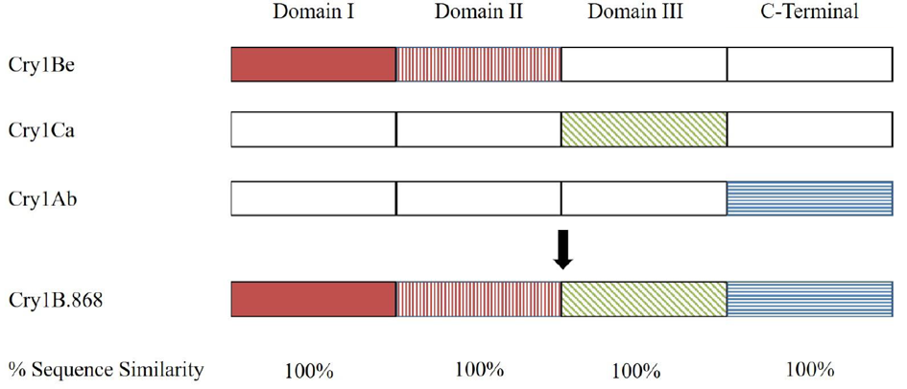
Figure 5. Representation of the domain architecture of the Cry1B.868 protein and similarity with derived sequences. Shading is used to differentiate the origin of the domains. The lengths of the domains in this schematic are not in proportion to the amino acid sequence.
B. thuringiensis and the Cry proteins have a long history of use in agriculture (Federici and Siegel, 2008). This use in agriculture mean humans have been exposed to over a hundred different Cry proteins, each with their own primary structure but with high similarities in secondary and tertiary structure, without adverse effects.
The Cry1Ab protein from B. thuringiensis subspecies kurstaki has been considered by FSANZ in four previous safety assessments. This includes A346 – corn line MON810 (FSANZ 2000), A385 – corn line BT176 (FSANZ 2001a), A386 – corn line BT11 (FSANZ, 2001b) and A615 – corn line COT67B (FSANZ 2009).
The Cry1B.868 gene prepared by the applicant encodes a protein of 1199 amino acids, with an apparent molecular weight of ~127 kDa.

4.1.1 Characterisation of Cry1B.868 expressed in MON95379 and equivalence to a bacterially-produced form
The equivalence of the MON95379- and B. thuringiensis-derived Cry1B.868 proteins must be established before the safety data generated using B. thuringiensis-derived Cry1B.868 can be applied to MON95379-derived Cry1B.868.
The plant-derived Cry1B.868 was purified from MON95379 grain. This included affinity chromatography to isolate any fraction bound to a Cry1B.868 antibody. The purified fractions containing Cry1B.868 were identified by SDS-PAGE and Western blot, and subsequently concentrated. B. thuringiensis-derived Cry1B.868 protein was generated from the fermentation of B. thuringiensis containing a plasmid that expresses Cry1B.868.
In order to confirm the identity and equivalence of the MON95379- and B. thuringiensis-derived Cry1B.868, a series of analytical techniques were employed. The results are summarised below.
Molecular weight. Samples of purified MON95379- and B. thuringiensis-derived Cry1B.868 were run on SDS-PAGE then visualised with Brilliant Blue G-Colloidal stain. The average purity of the MON95379-derived Cry1B.868 was calculate as 97%. The MON95379- and B. thuringiensis-derived Cry1B.868 were shown to have an apparent molecular weight of 126.8 and 129.6 kDa, respectively. These molecular weights are within acceptance limits for equivalence.
Immunoreactivity. Western blot analysis with a Cry1B.868-specific antibody showed that the protein being expressed in MON95379 and B. thuringiensis was in fact Cry1B.868 and they have equivalent immunoreactivity.
Peptide mapping. MON95379-derived Cry1B.868 was digested with trypsin and analysed via mass spectrometry. When peptides were mapped, the sequence coverage was 91% of the expected Cry1B.868 sequence (1088/1199 amino acids). B. thuringiensis-derived Cry1B.868 was similarly digested with trypsin and analysed via mass spectrometry. Matched peptides for B. thuringiensis-derived Cry1B.868 accounted for 96% of the expected Cry1B.868 sequence (1156/1199 amino acids). These results show that the protein being expressed in MON95379 and B. thuringiensis was in fact Cry1B.868.
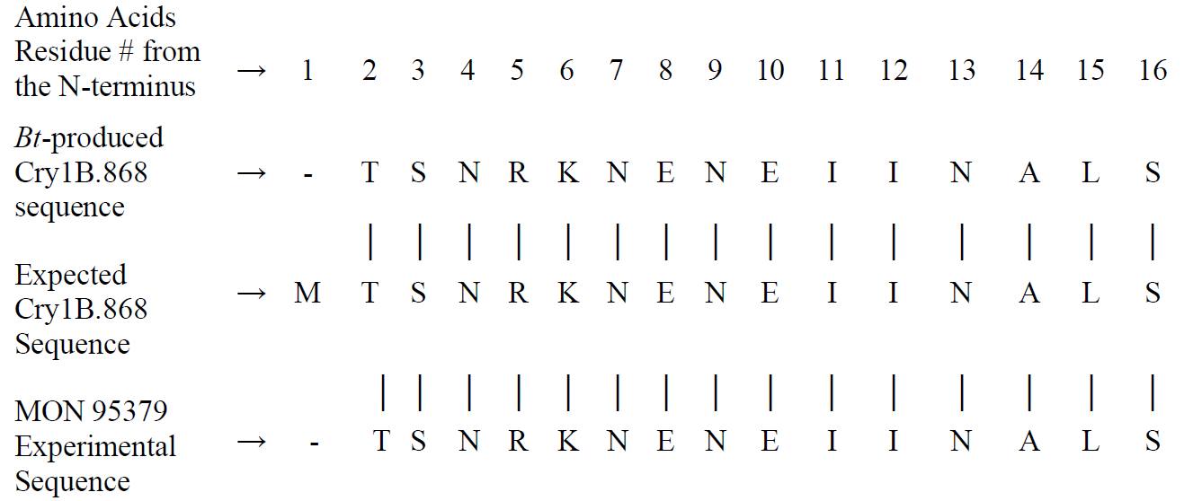
N-terminal sequencing. Amino acids 2-16 of MON95379- and B. thuringiensis-derived Cry1B.868 were sequenced and the sequence was as expected (Figure 6). The first N-terminal methionine residue in both proteins was most likely cleaved, which is a common process in many organisms (Wingfield, 2017).
Figure 6. N-terminal amino acid sequences of MON95379- and B. thuringiensis-derived Cry1B.868.
Glycosylation analysis. An SDS-PAGE and glycoprotein detection procedure involving enhanced chemiluminescence (ECL) showed that Cry1B.868 from both MON95379 and B. thuringiensis was equivalent and that neither is glycosylated. The positive control protein showed a band indicative of glycosylation.
Functional activity. The biological activity of MON95379- and B. thuringiensis-derived Cry1B.868 was evaluated in a 7-day insect bioassay. In this experiment, the EC₅₀ value was defined as the concentration of protein (µg Cry1B.868/ml diet) that causes 50% growth inhibition compared to the control treatment. Larvae fed a diet containing MON95379- and B. thuringiensis-derived Cry1B.868 showed a mean EC₅₀ of 0.15 and 0.20, respectively. These EC₅₀ values are within acceptance limits for equivalence.
The results outlined in this section demonstrated that B. thuringiensis-derived Cry1B.868 is structurally, biochemically and functionally equivalent to MON95379-derived Cry1B.868. It can be concluded that B. thuringiensis-derived Cry1B.868 is a suitable surrogate for use in the safety assessment experiments described in Section 4.1.3.

4.1.2 Expression of Cry1B.868 in MON95379 tissue
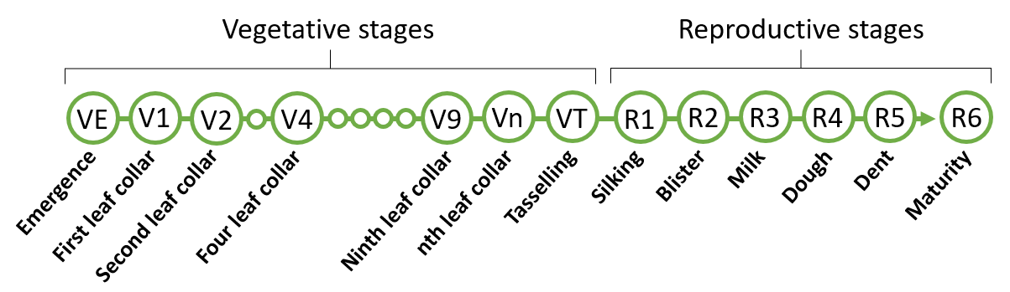
The levels of Cry1B.868 protein in MON95379 were quantified using a quantitative Enzyme-Linked ImmunoSorbent Assay (ELISA). An analytical reference for plant-derived Cry1B.868 protein was generated using B. thuringiensis-expressed Cry1B.868 protein, of which the characterisation is described in Section 4.1.1. Various tissues at different growth stages were examined. Figure 7 depicts the different growth stages in corn. For each tissue analysed, four samples were processed from each of the five field-trial sites. The study was conducted during the 2018 growing season in corn growing regions in the US.
Figure 7. Stages of corn growth. Grain is harvested at R6.
Results from the ELISA show that Cry1B.868 was detected in MON95379, with the highest expression in leaf in the early V2-V4 vegetative stage (Table 4). The lowest level of detection was in the grain at maturity (R6).
Table 4: Expression of Cry1B.868 (µg/g dw¹) in various tissues
Tissue | Growth Stage² | MON95379
 |  | Mean | SE³ | Range
Leaf | V2-V4 | 630 | 22 | 310 - 760
Root | V2-V4 | 110 | 8.2 | 67 - 210
Pollen | R1 | 91 | 2.1 | 73 - 110
Forage | R5 | 110 | 8.2 | 50 - 170
Grain | R6 | 26 | 3.5 | 7.8 - 77
1. dw - dry weight. 2. Growth Stage abbreviations – see Figure 7. 3. SE – standard error.

4.1.3 Safety of the introduced Cry1B.868
Data were provided to assess the potential toxicity and allergenicity of Cry1B.868.
Bioinformatic analyses of Cry1B.868
In silico analyses comparing the Cry1B.868 amino acid sequence to known allergenic proteins in the COMPARE database (AD_2020) and all proteins in the NCBI database (PRT_2020) were performed by the applicant. The same types of analyses as outlined in Section 3.4.5.1 were used. The search did not identify any known allergens with homology to Cry1B.868. No alignments had an E-score of ≤1×10⁻⁵ or met or exceeded the threshold of greater than 35% similarity over ≥ 80 amino acids and no eight amino acid peptide matches were shared between the Cry1B.868 sequence and proteins in the allergen database. The alignment to the PRT_2020 database self-identified the Cry1B.868 protein, which was expected.
The applicant provided the results of in silico analyses comparing the Cry1B.868 amino acid sequence to proteins identified as “toxins” in the same database described in Section 3.4.5.2 (TOX_2020). The same type of analysis as outlined in Section 3.4.5.2 was used. No alignments had an E-score of ≤1×10⁻⁵ indicating that the search did not identify any known toxins with homology to Cry1B.868.
Susceptibility of Cry1B.868 to digestion with pepsin and pancreatin
B. thuringiensis-produced Cry1B.868 (test protein) was incubated with pepsin (10U enzyme/μg protein) for 0-60 min in a 38.3°C water bath. Reactions occurred under acidic conditions in simulated gastric fluid (Thomas et al., 2004). Controls included a no test protein control (pepsin only) and no pepsin control (test protein only) incubated for 0 and 60 min. The extent of digestion was visualised by Brilliant Blue G-Colloidal stained SDS-PAGE and Western blotting. A serial dilution of the reaction mix (test protein plus pepsin) without incubation (0 min) was used to determine the limit of detection (LOD) for Cry1B.868 after gel staining and Western blotting. In the gel staining analysis, 1 µg test protein was loaded per lane and the LOD was calculated to be ~1.6 ng. In the Western blotting experiments, 40 ng test protein was loaded per lane and the LOD was ~0.63 ng.
Visual inspection of the pepsin digestion showed that by 0.5 min, there was no intact Cry1B.868 remaining in the reaction mix. Based on the LOD, it was calculated that >99.8% of the intact Cry1B.868 was digested within 0.5 min when analysed by SDS-PAGE and >98.4% when analysed by Western blot. This digestion was not complete however, with transiently-stable peptide fragments of ~4 kDa being observed in the stained SDS-PAGE at all digestion times (0.5 - 60 min). Cry1B.868 remained intact after 60 min in the simulated gastric fluid without pepsin. This control indicates that the rapid loss of Cry1B.868 protein in the reaction mixes is due to proteolytic digestion of Cry1B.868 by pepsin and not due to instability of the protein while in the simulated gastric fluid for 60 min.
B. thuringiensis-produced Cry1B.868 (test protein) was also incubated with pancreatin (~55 μg enzyme/μg protein) at 37.6°C for 0-24 h, in simulated intestinal fluid system at a neutral pH range. Controls for this experiment included a no test protein control (pancreatin only) and no pancreatin control (test protein only) incubated for 0 and 24 h. The extent of digestion was visualised by Western blot. A serial dilution of the reaction mix (test protein plus enzyme) without incubation (0 min) was used to determine the LOD for the protein in Western blot. In the experiment, 40 ng test protein was loaded per lane and the LOD was ~0.16 ng.
Visual inspection of the pancreatin digestion showed that by 5 min, there was no intact Cry1B.868 remaining in the reaction mix. Based on the LOD, it was calculated that >99.6% of the intact Cry1B.868 protein was digested within 5 min. There were bands of ~60 kDa present throughout the experiment corresponding to fragments of Cry1B.868. The presence of similar sized fragments has been observed in the digestion of other Cry proteins with pancreatin (e.g. Cry1A.105 and Cry2Ab2 proteins) and represents the protease-resistant core (FSANZ 2015). Other, smaller immunoreactive bands are noted as being transiently present but the majority disappeared over time. There was some protein instability in the no pancreatin control after 24 h incubation, indicated by additional bands immediately below the intact Cry1B.868. However, there was no major loss of band intensity for the intact Cry1B.868. It can be concluded that the loss of the intact Cry1B.868 in the reaction mix was due to pancreatin.
In the human digestive system, gastric digestion (pepsin) occurs before intestinal digestion (pancreatin). Therefore a sequential digestion was performed on Cry1B.868. The pepsin digestion was run for 2 min followed by digestion by pancreatin for 0-2 h. The results showed that by 2 min, intact Cry1B.868 was digested by the pepsin and the small transiently-stable peptide fragments of ~4 kDa were completely digested within 0.5 min of pancreatin exposure. No other bands were present in the 0.5 min sequential digestion, other than those found in the controls. Together, these data indicate that Cry1B.868 will be fully degraded by gastric and intestinal enzymes in the human digestive system.
Structural stability and bioactivity of Cry1B.868 after exposure to heat
B. thuringiensis-produced Cry1B.868 was heated for 15 or 30 min at temperatures ranging from 25-95°C. A control sample was kept on wet ice (~0°C). An aliquot of the control and heated protein samples were run on an SDS-PAGE and stained with Brilliant Blue G-Colloidal stain to detect the extent of protein degradation, i.e. structural stability. No visible degradation or decrease in band intensity was observed for Cry1B.868 in the control, 25, 37 and 55°C treated samples at both 15 and 30 min. At 75°C, smaller molecular weight degradation products were present and a more prominent loss of band intensity of Cry1B.868 at 30 min was observed. The samples treated at 95°C for 15 and 30 min had a significant loss of Cry1B.868 band intensity. Using the Cry1B.868 reference standard, the loss of band intensity at 95°C for 30 min was ~10% of the original amount of protein loaded. Relative to the 75°C samples, an increase in degradation products was observe at 95°C for 15 and 30 min. These data indicate that Cry1B.868 is heat labile at temperatures greater than 75°C.
In addition to the degradation of Cry1B.868 at higher temperatures, heat may impact its functionality (bioactivity). To this end, the heated protein samples were tested in a bioassay that measured the mass of insect larvae fed a diet of Cry1B.868 for 7 days. The bioactivity for each sample was measured as an EC₅₀ value. This is the effective Cry1B.868 concentration that results in a 50% growth inhibition relative to control insects. The control insects had a diet of Cry1B.868 that was kept on wet ice (~0°C). At heating temperatures of 25-55°C and for either 15 or 30 min, the ability of Cry1B.868 to inhibit insect growth remained similar to the unheated Cry1B.868 (Tables 5 and 6). There was a large reduction in bioactivity of Cry1B.868 at temperatures of 75°C and above for either 15 or 30 min. This was calculated as a reduction of >98% functional activity when compared to the control. These data indicate that at elevated temperatures Cry1B.868 becomes denatured and loses bioactivity.
Table 5: Bioactivity of heat-treated Cry1B.868 (15 min) in a diet fed to insect larvae
Temperature | EC₅₀  (μg Cry1B.868/ml diet) | 95% CIª  (μg Cry1B.868/ml diet)
0°C (control) | 0.18 | 0.15 - 0.21
25°C | 0.18 | 0.13 - 0.24
37°C | 0.085 | 0.0^{b} - 0.17
55°C | 0.14 | 0.078 - 0.21
75°C | >10^{c} | —
95°C | >10^{c} | —
a. Confidence limits
b. Lower limit manually replaced with ‘0.0’ value
c. 10 μg Cry1B.868/ml diet represents the highest concentration tested
Table 6: Bioactivity of heat-treated Cry1B.868 (30 min) in a diet fed to insect larvae
Temperature | EC₅₀  (μg Cry1B.868/ml diet) | 95% CI  (μg Cry1B.868/ml diet)
0°C (control) | 0.18 | 0.15 - 0.21
25°C | 0.09 | 0.061 - 0.12
37°C | 0.14 | 0.072 - 0.21
55°C | 0.16 | 0.051 - 0.26
75°C | >10ª | —
95°C | >10ª | —
a. 10 μg Cry1B.868/ml diet represents the highest concentration tested

4.1.4 Conclusion
A range of characterisation studies were performed on plant-derived Cry1B.868 confirming its identity, structure, biochemistry and function, as well as equivalence of the corresponding protein produced using a B. thuringiensis expression system. Expression of Cry1B.868 in MON95379 was highest in leaf tissue and lowest in grain. Bioinformatic analyses showed Cry1B.868 had no homology to known toxins and allergens. Cry1B.868 was heat labile and susceptible to pepsin and pancreatin digestion. Taken together this indicates that the Cry1B.868 protein is unlikely to be toxic or allergenic to humans.

4.2 Cry1Da_7
Cry1Da_7 is a modified version of the Cry1Da protein, sharing 99.7% sequence similarity or four amino acid differences (Figure 8). This includes an additional alanine at position 2 of domain I, and three amino acid substitutions in domain II: Serine to valine at position 282, tyrosine to serine at position 316, and isoleucine to proline at position 368. The addition of alanine at the beginning of the Cry1Da_7 sequence was to optimise the codon for translation in planta. The amino acid substitutions in domain II improve the activity of the protein towards corn earworm (relative to Cry1Da), while maintaining activity towards fall armyworm (Wang et al., 2019).
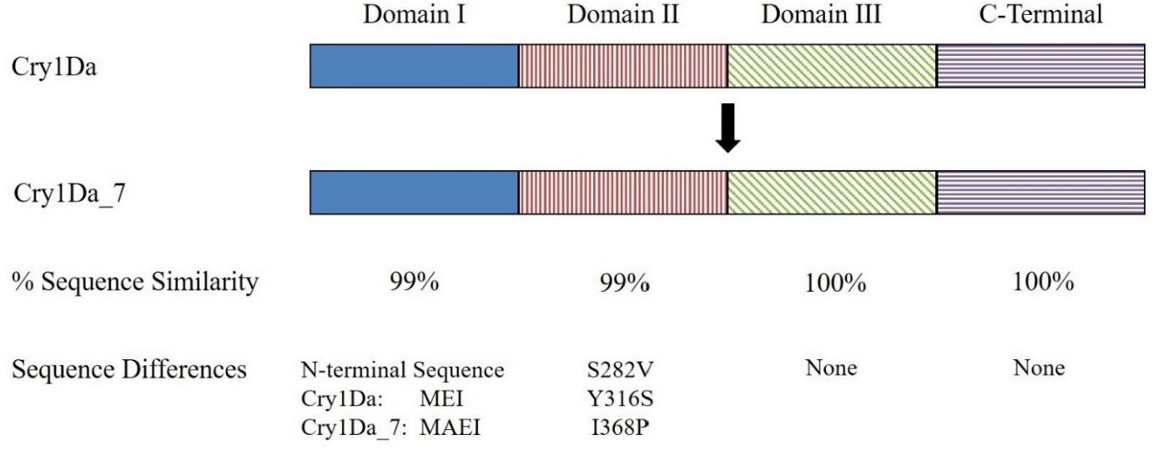
Figure 8: Representation of the domain architecture of Cry1Da_7 and similarity with Cry1Da. Shading is used to differentiate the domains. The lengths of the domains in this schematic are not in proportion to the amino acid sequence.
As described in Section 2.2.1 and Section 4.1, there is a long history of use of B. thuringiensis in agriculture. Specifically, the Cry1Da protein is present in B. thuringiensis subspecies aizawai isolate HD137. This is a wild-type isolate whose spore-crystal preparations are used commercially for insect control (Bravo et al., 2011). Hence there is a history of human exposure to this specific protein.
The Cry1Da_7 gene prepared by the applicant encodes a protein of 1166 amino acids, with an apparent molecular weight of ~132 kDa.

4.2.1 Characterisation of Cry1Da_7 expressed in MON95379 and equivalence to a bacterially-produced form
The equivalence of the MON95379- and B. thuringiensis-derived Cry1Da_7 must be established before the safety data generated using B. thuringiensis-derived Cry1Da_7 can be applied to MON95379-derived Cry1Da_7.
The plant-derived Cry1Da_7 was purified from MON95379 grain. This included affinity chromatography to isolate any fraction bound to a Cry1Da_7 antibody. The purified fractions containing Cry1Da_7 were identified by SDS-PAGE and Western blot, and subsequently concentrated. B. thuringiensis-derived Cry1Da_7 was generated from the fermentation of B. thuringiensis containing a plasmid that expresses Cry1Da_7.
In order to confirm the identity and equivalence of the MON95379- and B. thuringiensis-derived Cry1Da_7, a series of analytical techniques were employed. The results are summarised below.
Molecular weight. Samples of purified MON95379- and B. thuringiensis-derived Cry1Da_7 were run on SDS-PAGE then visualised with Brilliant Blue G-Colloidal stain. The average purity of the MON95379-derived Cry1Da_7 was calculate as 52%. The MON95379- and B. thuringiensis-derived Cry1Da_7 were shown to have an apparent molecular weight of 132.1 and 126.5 kDa, respectively. These molecular weights are within acceptance limits for equivalence.
Immunoreactivity. Western blot analysis with a Cry1Da_7-specific antibody showed that the protein being expressed in MON95379 and B. thuringiensis was in fact Cry1Da_7 and they have equivalent immunoreactivity.
Peptide mapping. MON95379-derived Cry1Da_7 was digested with trypsin and analysed via mass spectrometry. When peptides were mapped, the sequence coverage was 89% of the expected Cry1Da_7 sequence (1049/1166 amino acids). B. thuringiensis-derived Cry1Da_7 was similarly digested with trypsin and analysed via mass spectrometry. Matched peptides for B. thuringiensis-derived Cry1Da_7 also accounted for 89% of the expected Cry1Da_7 sequence (1049/1166 amino acids). These results show that the protein being expressed in MON95379 and B. thuringiensis was in fact Cry1Da_7.
N-terminal sequencing. Amino acids 2-16 of MON95379- and B. thuringiensis-derived Cry1Da_7 were sequenced and the sequence was as expected (Figure 9). Similar to Cry1B.868, the first N-terminal methionine residue in both proteins was most likely cleaved. This is a common process in many organisms (Wingfield, 2017).
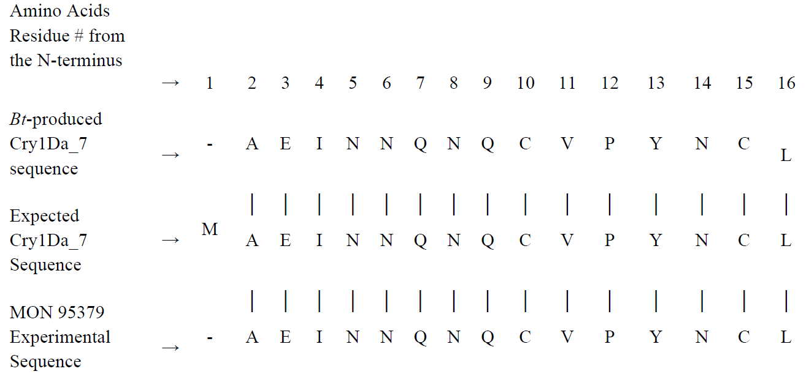Figure 9. N-terminal amino acid sequences of MON95379- and B. thuringiensis-derived Cry1Da_7.
Glycosylation analysis. An SDS-PAGE and glycoprotein detection procedure involving ECL showed that Cry1Da_7 from both MON95379 and B. thuringiensis was equivalent and that neither is glycosylated. The positive control protein showed a band indicative of glycosylation.
Functional activity. The biological activity of MON95379- and B. thuringiensis-derived Cry1Da_7 was evaluated in a 7-day insect bioassay. In this experiment, the EC₅₀ value was defined as the concentration of protein (µg Cry1Da_7/ml diet) that causes 50% growth inhibition compared to the control treatment. Larvae fed a diet containing MON95379- and B. thuringiensis-derived Cry1B.868 showed a mean EC₅₀ of 0.17 and 0.12, respectively. These EC₅₀ values are within acceptance limits for equivalence.
The data outlined in this section demonstrated that B. thuringiensis-derived Cry1Da_7 is structurally, biochemically and functionally equivalent to MON95379-derived Cry1Da_7. It can be concluded that B. thuringiensis-derived Cry1Da_7 is a suitable surrogate for use in the safety assessment experiments described in Section 4.2.3.

4.2.2 Expression of Cry1Da_7 in MON95379 tissue
The levels of Cry1Da_7 expression in plant tissues was determined in the same ELISA study as described in Section 4.1.2. The analytical reference for plant-derived Cry1Da_7, however, was generated using B. thuringiensis-expressed Cry1Da_7, of which the characterisation is described in Section 4.2.1.
The results from the expression analysis showed the highest levels of Cry1Da_7 was in leaf tissue (Table 7). Cry1Da_7 levels were below the limit of quantitation (LOQ) in pollen, with the lowest quantifiable level observed in grain.

Table 7: Expression of Cry1B.868 (µg/g dw¹) in various tissues
Tissue | Growth Stage² | MON95379
 |  | Mean | SE³ | Range
Leaf | V2-V4 | 92 | 5.2 | 56 - 140
Root | V2-V4 | 43 | 3.1 | 26 - 72
Pollen | R1 | < LOQ | – | –
Forage | R5 | 26 | 2.1 | 13 - 50
Grain | R6 | 0.25 | 0.032 | 0.13 - 0.64
1. dw - dry weight. 2. Growth Stage abbreviations – see Figure 7. 3. SE – standard error.

4.2.3 Safety of the introduced Cry1Da_7
Data were provided to assess the potential toxicity and allergenicity of Cry1Da_7.
Bioinformatic analyses of Cry1Da_7
In silico analyses comparing the Cry1Da_7 amino acid sequence to known allergenic proteins in the COMPARE database (AD_2020) and all proteins in the NCBI database (PRT_2020) were performed by the applicant. The same types of analyses as outlined in Section 3.4.5 were used. The search did not identify any known allergens with homology to Cry1Da_7. Furthermore, no alignments had an E-score of ≤1×10⁻⁵ and no eight amino acid peptide matches were shared between the Cry1B.868 sequence and proteins in the allergen database. The alignment to the PRT_2020 database self-identified the Cry1Da_7 protein, which was expected.
The applicant provided the results of in silico analyses comparing the Cry1Da_7 amino acid sequence to proteins identified as “toxins” in the same database described in Section 3.4.5.2 (TOX_2020). The same type of analysis as outlined in Section 3.4.5.2 was used. No alignments had an E-score of ≤1×10⁻⁵ indicating that the search did not identify any known toxins with homology to Cry1Da_7.
Susceptibility of Cry1Da_7 to digestion with pepsin and pancreatin
B. thuringiensis-produced Cry1Da_7 (test protein) was incubated with pepsin (10U enzyme/μg protein) for 0-60 min in a 38°C water bath. Reactions occurred under acidic conditions in simulated gastric fluid (Thomas et al., 2004). Controls included a no test protein control (pepsin only) and no pepsin control (test protein only) incubated for 0 and 60 min. The extent of digestion was visualised by Brilliant Blue G-Colloidal stained SDS-PAGE and Western blotting. A serial dilution of the reaction mix (test protein plus pepsin) without incubation (0 min) was used to determine the LOD for Cry1Da_7 after gel staining and Western blotting. In the gel staining analysis, 1 µg test protein was loaded per lane and the LOD was calculated to be ~6.3 ng. In the Western blotting experiments, 40 ng test protein was loaded per lane and the LOD was ~1.25 ng.
Visual inspection of the pepsin digestion showed that by 0.5 min, there was no intact Cry1Da_7 remaining in the reaction mix. Based on the LOD, it was calculated that >99.4% of the intact Cry1Da_7 protein was digested within 0.5 min when analysed by SDS-PAGE and >96.9% when analysed by Western blot. This digestion was not complete however, with transiently-stable peptide fragments of ~4 kDa being observed in the stained SDS-PAGE at all digestion times (0.5 - 60 min). Cry1Da_7 protein remained intact after 60 min in the simulated gastric fluid without pepsin. This control indicates that the rapid loss of Cry1Da_7 protein in the reaction mixes is due to proteolytic digestion of Cry1Da_7 by pepsin and not due to instability of the protein while in the simulated gastric fluid for 60 min.
B. thuringiensis-produced Cry1Da_7 (test protein) was also incubated with pancreatin (~55 μg enzyme/μg protein) at 37.7°C for 0-24 h, in simulated intestinal fluid system at a neutral pH range. Controls for this experiment included a no test protein control (pancreatin only) and no pancreatin control (test protein only) incubated for 0 and 24 h. The extent of digestion was visualised by Western blot. A serial dilution of the reaction mix (test protein plus enzyme) without incubation (0 min) was used to determine the LOD for the protein in Western blot. In the experiment, 40 ng test protein was loaded per lane and the LOD was ~1.25 ng.
Visual inspection of the pancreatin digestion showed that by 5 min, there was no intact Cry1Da_7 remaining in the reaction mix. Based on the LOD, it was calculated that >96.9% of intact Cry1Da_7 was digested within 5 min. There were bands of ~60 kDa present throughout the experiment corresponding to fragments of Cry1Da_7. The presence of similar sized fragments has been observed in the digestion of other Cry proteins with pancreatin (e.g. Cry1B.868, Cry1A.105 and Cry2Ab2 proteins) and represents the protease-resistant core (FSANZ 2015). There was no major loss of band intensity for intact Cry1Da_7 in the no pancreatin control after 24 h incubation. It can be concluded that the loss of the intact Cry1Da_7 protein in the reaction mix was due to pancreatin.
In the human digestive system, gastric digestion (pepsin) occurs before intestinal digestion (pancreatin). Therefore a sequential digestion was performed on Cry1Da_7. The pepsin digestion was run for 2 min followed by digestion by pancreatin for 0-2 h. The results showed that by 2 min, intact Cry1Da_7 was digested by the pepsin and the small transiently-stable peptide fragments of ~4 kDa were completely digested within 0.5 min of pancreatin exposure. By 2 min of sequential digestion, no other bands were present other than those found in the no test protein 0 min sequential digestion control, i.e. bands are representative of pancreatin. Together, these data indicate that Cry1Da_7 will be fully degraded by gastric and intestinal enzymes in the human digestive system.
Structural stability and bioactivity of Cry1Da_7 after exposure to heat
B. thuringiensis-produced Cry1Da_7 was heated for 15 or 30 min at temperatures ranging from 25-95°C. A control sample was kept on wet ice (~0°C). An aliquot of the control and heated protein samples were run on an SDS-PAGE and stained with Brilliant Blue G-Colloidal stain to detect the extent of protein degradation. No visible degradation or decrease in band intensity was observed for Cry1Da_7 in the control, 25, 37 and 55°C treated samples at both 15 and 30 min. At 75°C for 15 min, the intensity of the Cry1Da_7 band decreased, with a more substantial decrease at 30 min. The sample treated at 95°C for 15 min had a considerable loss of Cry1Da_7 band intensity. Using the Cry1Da_7 reference standard, the loss of band intensity was < 10% of the original amount of protein loaded. At 95°C or 30 min, the Cry1Da_7 band was absent. Smaller molecular weight degradation products were present in samples incubated at 95°C for both 15 and 30 min. These data indicate that Cry1Da_7 is heat labile at temperatures greater than 75°C.
In addition to the degradation of Cry1Da_7 at higher temperatures, heat may impact its functionality (bioactivity). To this end, the heated protein samples were tested in a bioassay that measured the mass of insect larvae fed a diet of Cry1Da_7 for 7 days. The bioactivity for each sample was measured as an EC₅₀ value. This is the effective Cry1Da_7 concentration that results in a 50% growth inhibition relative to control insects. The control insects had a diet of Cry1Da_7 that was kept on wet ice (~0°C). At heating temperatures of 25-55°C and for either 15 or 30 min, the ability of Cry1Da_7 to inhibit insect growth remained similar to the unheated Cry1Da_7 (Table 8 and 9). There was a large reduction in bioactivity of Cry1Da_7 at temperatures of 75°C and above for either 15 or 30 min. This was calculated as a reduction of >98% functional activity when compared to the control. These data indicate that at elevated temperatures Cry1Da_7 becomes denatured and loses bioactivity.
Table 8: Bioactivity of heat-treated Cry1Da_7 (15 min) in a diet fed to insect larvae
Temperature | EC₅₀  (μg Cry1Da_7/ml diet) | 95% CIª  (μg Cry1Da_7/ml diet)
0°C (control) | 0.16 | 0.14 - 0.18
25°C | 0.11 | 0.086 - 0.13
37°C | 0.16 | 0.11 - 0.22
55°C | 0.12 | 0.097 - 0.14
75°C | 9.60 | 0.0^{b} - 25
95°C | >10^{c} | —
a. Confidence limits
b. Lower limit manually replaced with ‘0.0’ value
c. 10 μg Cry1Da_7/ml diet represents the highest concentration tested
Table 9: Bioactivity of heat-treated Cry1Da_7 (30 min) in a diet fed to insect larvae
Temperature | EC₅₀  (μg Cry1Da_7/ml diet) | 95% CI  (μg Cry1Da_7/ml diet)
0°C (control) | 0.16 | 0.14 - 0.18
25°C | 0.12 | 0.096 - 0.14
37°C | 0.071 | 0.044 - 0.098
55°C | 0.13 | 0.10 - 0.17
75°C | >10ª | —
95°C | >10ª | —
a. 10 μg Cry1Da_7 /ml diet represents the highest concentration tested

4.2.4 Conclusion
A range of characterisation studies were performed on plant-derived Cry1Da_7 confirming its identity, structure, biochemistry and function, as well as equivalence of the corresponding protein produced using a B. thuringiensis expression system. Expression of Cry1Da_7 in MON95379 was highest in leaf tissue and lowest in pollen, followed by grain. Bioinformatic analyses showed Cry1Da_7 had no homology to known toxins and allergens. Cry1Da_7 was heat labile and susceptible to pepsin and pancreatin digestion. Taken together this indicates that the Cry1Da_7 protein is unlikely to be toxic or allergenic to humans.

5 Compositional analysis
The main purpose of compositional analyses is to determine if, as a result of the genetic modification, an unexpected change has occurred to the food. These changes could take the form of alterations in the composition of the plant and its tissues and thus its nutritional adequacy. Compositional analyses can also be important for evaluating the intended effect where there has been a deliberate change to the composition of the food.
The classic approach to the compositional analyses of GM food is a targeted one. Rather than analysing every possible constituent, which would be impractical, the aim is to analyse only those constituents most relevant to the safety of the food or that may have an impact on the whole diet. Important analytes therefore include the key nutrients, toxicants and anti-nutrients for the food in question. The key nutrients and anti-nutrients are those components in a particular food that may have a substantial impact in the overall diet. They may be major constituents (fats, proteins, carbohydrates or enzyme inhibitors such as anti-nutrients) or minor constituents (minerals, vitamins). Key toxicants are those toxicologically significant compounds known to be inherently present in an organism, such as compounds whose toxic potency and level may be significant to health.

5.1 Key components
The key components to be analysed for the comparison of transgenic and conventional corn are outlined in the OECD Consensus Document on Compositional Considerations for New Varieties of Maize (OECD 2002), and include: proximates (protein, fat, fibre, ash, carbohydrates), amino acids, fatty acids, minerals, vitamins and the anti-nutrients phytic acid, raffinose, furfual and the phenolic acids ferulic acid and p-coumaric acid.

5.2 Study design
MON95379 was grown and harvested from five field trial sites in the US during the 2018 growing season. The sites were representative of corn growing regions suitable for commercial production. The materials tested in the field trials included MON95379 generation F5F1 and the non-GM conventional control (LH244 x HCL617). The field sites were established in a randomised complete block design with four replicates per site. Plants were grown under agronomic field conditions as per each of the different growing regions.
Grain was harvested from all plots at maturity and shipped to an analytical laboratory at ambient temperature. Compositional analyses were performed at Eurofins Food Integrity & Innovation. These analyses were based on internationally recognised procedures including official methods specified by the Association of Official Analytical Chemists (AOAC), the Analytical Oil Chemists' Society (AOCS), methods specified by the manufacturer of the equipment used for analysis, or other published scientific methods.
Sixty eight different analytes were measured in grain (listed in Table 10). Moisture was one of these analytes and was used to convert the remaining analyte values from fresh to dry weight. Statistical analyses were performed using SAS 9.4 (SAS Institute, Cary, North Carolina). The majority of analytes are expressed on a percent dry weight (% dw) basis. Vitamins and some minerals are expressed as milligrams per kilogram dw, fatty acids are expressed as percent of total fatty acids and secondary metabolites are expressed as micrograms per gram dw. A linear mixed model analysis of variance was applied on data combined across all the five replicated field trial sites. For each analyte, ‘descriptive statistics’ (mean, standard error (SE), and range) were generated. Any analyte with more than 50% of observations below the LOQ were excluded from the statistical analysis and table summaries below (Tables 11-16). In total, there were 15 analytes excluded on this bases.
In assessing the significance of any difference between MON95379 and the control, a P-value of 0.05 was used. Any statistically significant differences were evaluated further. First, the magnitude of difference in mean values between MON95379 and the control were determined (denoted as ‘Mean difference’ in Tables 11-16). Second, this difference was compared to the variation observed within the control grown at multiple sites. This variation was calculated from the range value of the control (maximum minus the minimum value; denoted as ‘Control range value’ in Tables 11-16) and shows the natural variability of analytes in a plant with a similar background to MON95379 grown under the same agronomical and environmental conditions, i.e. 5 field trial sites. Finally, the natural variation of analytes from publically available data was also considered (ILSI 2019; Ridley et al., 2011; Harrigan et al., 2009; Egesel et al., 2003). This takes into account variability present in non-GM corn cultivars due to a wider range of agronomic and environment conditions, as well as different genetic backgrounds. These data ranges assist with determining whether any statistically significant differences were likely to be biologically meaningful.
Key analyte levels (proximates and minerals) were also analysed in forage but the results are not included in this report. It is noted however that, in the combined site analysis, none of the analyte levels in MON95379 differed significantly from those of the control.
Table 10: Analytes measured in the grain samples
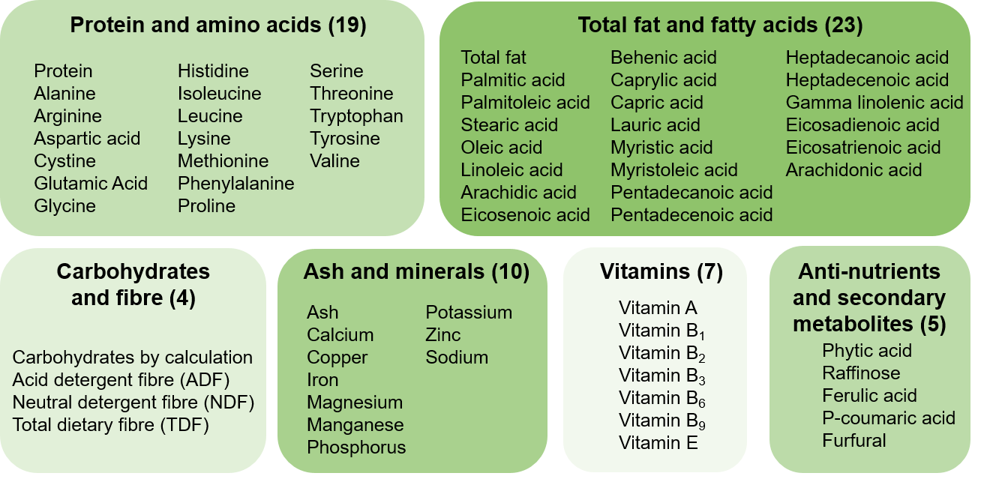

5.3 Analyses of key components in grain

5.3.1 Protein and amino acids
A statistically significant difference was observed in MON95379 compared to the control for protein and the amino acids alanine, glutamic acid, isoleucine, leucine, methionine, phenylalanine, serine, threonine and valine (Table 11). However, the magnitude of mean differences were all less than the corresponding control range value and the observed MON95379 means fall within the natural variability seen in the publically available data. These differences are considered minor and are not biologically significant.
No other statistically significant differences in amino acids were observed between MON95379 and the control (Table 11). Means were also within the natural variability of analytes seen in publically available data.
Table 11: Comparison of protein and amino acids (% dw)
Analyte | Control Mean (SE)  Range | MON95379 Mean (SE)  Range | P-value | Mean difference (SE) | Control range value | Publically available data
Protein | 9.18 (0.56)  7.54 - 11.58 | 9.61 (0.56)  7.97 - 12.47 | 0.012 | 0.43  (0.16) | 4.04 | 5.72 - 17.26
Alanine | 0.71 (0.051) 0.56 - 0.93 | 0.75 (0.051) 0.59 - 1.02 | 0.027 | 0.035 (0.015) | 0.37 | 0.40 - 1.48
Arginine | 0.46 (0.019) 0.40 - 0.53 | 0.48 (0.019) 0.40 - 0.56 | ns¹ | 0.016 (0.0082) | 0.13 | 0.12 - 0.71
Aspartic acid | 0.59 (0.030) 0.50 - 0.71 | 0.60 (0.030) 0.53 - 0.76 | ns | 0.017 (0.0085) | 0.22 | 0.30 - 1.21
Cystine | 0.21 (0.010) 0.18 - 0.25 | 0.22 (0.010) 0.17 - 0.28 | ns | 0.0060 (0.0048) | 0.070 | 0.12 - 0.51
Glutamic acid | 1.71 (0.13) 1.36 - 2.28 | 1.80 (0.13)  1.41 - 2.51 | 0.012 | 0.096 (0.035) | 0.92 | 0.83 - 3.54
Glycine | 0.36 (0.013) 0.31 - 0.41 | 0.37 (0.013) 0.32 - 0.43 | ns | 0.0085 (0.0054) | 0.095 | 0.184 - 0.685
Histidine | 0.25 (0.013) 0.21 - 0.31 | 0.25 (0.013) 0.20 - 0.32 | ns | 0.0063 (0.0048) | 0.11 | 0.14 - 0.46
Isoleucine | 0.33 (0.023) 0.27 - 0.43 | 0.34 (0.023) 0.28 - 0.45 | 0.019 | 0.015 (0.0059) | 0.16 | 0.18 - 0.69
Leucine | 1.17 (0.10) 0.91 - 1.62 | 1.24 (0.10)  0.93 - 1.74 | 0.012 | 0.070 (0.026) | 0.71 | 0.60 - 2.49
Lysine | 0.26 (0.0062) 0.22 - 0.31 | 0.26 (0.0062) 0.21 - 0.30 | ns | 0.0011 (0.0067) | 0.087 | 0.129 - 0.668
Methionine | 0.21 (0.013) 0.17 - 0.27 | 0.22 (0.013) 0.18 - 0.29 | 0.008 | 0.012 (0.0042) | 0.098 | 0.11 - 0.47
Phenylalanine | 0.47 (0.035) 0.38 - 0.63 | 0.49 (0.035) 0.40 - 0.67 | 0.025 | 0.023 (0.0093) | 0.25 | 0.24 - 0.93
Proline | 0.86 (0.055) 0.69 - 1.07 | 0.88 (0.055) 0.71 - 1.15 | ns | 0.028 (0.015) | 0.38 | 0.46 - 1.75
Serine | 0.45 (0.029) 0.37 - 0.56 | 0.48 (0.029) 0.40 - 0.65 | 0.009 | 0.024 (0.0085) | 0.19 | 0.15 - 0.77
Threonine | 0.33 (0.018) 0.28 - 0.41 | 0.34 (0.018) 0.30 - 0.44 | 0.048 | 0.011 (0.0052) | 0.12 | 0.17 - 0.67
Tryptophan | 0.074 (0.0036) 0.066 - 0.090 | 0.077 (0.0036) 0.065 - 0.097 | ns | 0.0027 (0.0013) | 0.025 | 0.027 - 0.215
Tyrosine | 0.40 (0.027) 0.33 - 0.51 | 0.42 (0.027) 0.35 - 0.57 | ns | 0.020 (0.0084) | 0.17 | 0.10 - 0.73
Valine | 0.43 (0.024) 0.36 - 0.53 | 0.45 (0.024) 0.39 - 0.57 | 0.038 | 0.016 (0.0076) | 0.17 | 0.27 - 0.86
Cells highlighted in blue show statistically significant differences. 1. ns – not significant

5.3.2 Total fat and fatty acids
A statistically significant difference was observed in MON95379 compared to the control for linolenic acid (Table 12). However, the magnitude of mean difference was less than the control range value and the observed MON95379 mean falls within the natural variability seen in the publically available data. This difference is considered minor and is not biologically significant.
Total fat and all other fatty acids did not show statistically significant differences between MON95379 and the control (Table 12). Means were also within the natural variability of analytes seen in publically available data.
The following fatty acids were excluded from the Table 12 summary due to levels below the LOQ: caprylic acid, capric acid, lauric acid, myristic acid, myristoleic acid, pentadecanoic acid, pentadecenoic acid, heptadecanoic acid, heptadecenoic acid, gamma linolenic acid, eicosadienoic acid, eicosatrienoic acid and arachidonic acid.
Table 12: Comparison of total fat (% dw) and fatty acids (% total fat)
Analyte | Control Mean (SE)  Range | MON95379 Mean (SE)  Range | P-value | Mean difference (SE) | Control range value | Publically available data
Total fat | 3.80 (0.038) 3.59 - 4.06 | 3.86 (0.038) 3.69 - 4.08 | ns¹ | 0.059 (0.039) | 0.47 | 1.363 - 7.830
Palmitic acid | 12.79 (0.11) 12.15 - 13.58 | 12.69 (0.11) 12.31 - 13.06 | ns | -0.097 (0.080) | 1.43 | 6.81 - 26.55
Palmitoleic acid | 0.13 (0.0020) 0.12 - 0.14 | 0.13 (0.0020) 0.12 - 0.14 | ns | -0.00093 (0.0017) | 0.026 | 0.059 - 0.453
Stearic acid | 1.66 (0.027) 1.58 - 1.81 | 1.64 (0.027) 1.54 - 1.76 | ns | -0.023 (0.013) | 0.24 | 1.02 - 3.83
Oleic acid | 28.41 (0.23) 27.77 - 29.50 | 28.31 (0.23) 27.17 - 29.45 | ns | -0.10 (0.13) | 1.74 | 16.38 - 42.81
Linoleic acid | 54.99 (0.37) 52.94 - 56.19 | 55.24 (0.37) 53.67 - 56.93 | ns | 0.25 (0.16) | 3.26 | 34.27 - 67.68
Linolenic acid | 1.17 (0.016) 1.11 - 1.27 | 1.15 (0.016) 1.09 - 1.22 | 0.022 | -0.023 (0.0091) | 0.17 | 0.55 - 2.33
Arachidic acid | 0.41 (0.0084) 0.39 - 0.45 | 0.41 (0.0084) 0.39 - 0.45 | ns | -0.0046 (0.0037) | 0.061 | 0.267 - 0.993
Eicosenoic acid | 0.26 (0.0023) 0.25 - 0.28 | 0.26 (0.0023) 0.25 - 0.28 | ns | -0.00042 (0.0024) | 0.033 | 0.098 - 1.952
Behenic acid | 0.17 (0.0047) 0.15 - 0.18 | 0.16 (0.0047) 0.15 - 0.19 | ns | -0.0042 (0.0021) | 0.039 | 0.069 - 0.417
Cells highlighted in blue show statistically significant differences. 1. ns – not significant

5.3.3 Carbohydrates and fibre
A statistically significant difference was observed in MON95379 compared to the control for carbohydrates by calculation (Table 13). However, the magnitude of the mean difference was less than the control range value and the observed MON95379 mean falls within the natural variability seen in the publically available data. This difference is considered minor and is not biologically significant.
There were no statistically significant differences found in the level of fibre in MON95379 compared to the control (Table 13). Means were also within the natural variability of analytes seen in publically available data.
Table 13: Comparison of carbohydrates by calculation and fibre (% dw)
Analyte | Control Mean (SE)  Range | MON95379 Mean (SE)  Range | P-value | Mean difference (SE) | Control range value | Publically available data
Carbohydrates by calculation | 85.73 (0.61) 83.22 - 87.53 | 85.23 (0.61) 82.24 - 87.10 | 0.005 | -0.50  (0.16) | 4.31 | 77.4 - 89.7
ADF | 3.51 (0.098) 2.71 - 4.17 | 3.65 (0.098) 2.92 - 4.55 | ns¹ | 0.14  (0.12) | 1.45 | 1.41 - 11.34
NDF | 9.26 (0.15) 8.67 - 10.52 | 9.26 (0.15) 7.54 - 10.28 | ns | -0.0022 (0.22) | 1.86 | 4.28 - 24.30
TDF | 12.17 (0.22) 11.02 - 14.32 | 12.14 (0.22) 10.80 - 13.63 | ns | -0.024 (0.25) | 3.30 | 5.78 - 35.31
Cells highlighted in blue show statistically significant differences. 1. ns – not significant

5.3.4 Ash and minerals
A statistically significant difference was observed in MON95379 compared to the control for the minerals copper, iron, zinc, manganese, and phosphorus (Table 14). However, the magnitude of mean differences were all less than the corresponding control range value and the observed MON95379 means fall within the natural variability seen in the publically available data. These difference are considered minor and are not biologically significant.
No statistically significant differences in ash and other minerals were observed between MON95379 and the control (Table 14). Means were also within the natural variability of analytes seen in publically available data.
Sodium was excluded from the Table 14 summary due to its levels being below the LOQ.
Table 14: Comparison of ash and minerals
Analyte | Control Mean (SE)  Range | MON95379 Mean (SE)  Range | P-value | Mean difference (SE) | Control range value | Publically available data
Ash  (% dw) | 1.28 (0.024) 1.12 - 1.41 | 1.29 (0.024) 1.14 - 1.42 | ns¹ | 0.012 (0.022) | 0.29 | 0.616 - 6.282
Calcium  (% dw) | 0.0033 (0.00013) 0.0027 - 0.0044 | 0.0033 (0.00013) 0.0026 - 0.0040 | ns | 0.00001 (0.00004) | 0.0017 | 0.001 - 0.101
Copper (mg/kg dw) | 1.31 (0.095) 0.97 - 1.75 | 1.48 (0.095) 1.14 - 2.02 | 0.038 | 0.18 (0.058) | 0.78 | 0.55 - 21.20
Iron  (mg/kg dw) | 16.35 (0.45) 14.48 - 18.72 | 17.16 (0.45) 14.38 - 19.63 | 0.001 | 0.81  (0.23) | 4.24 | 9.51 - 191.00
Magnesium (% dw) | 0.10 (0.0045) 0.086 - 0.13 | 0.11 (0.0045) 0.090 - 0.13 | ns | 0.0027 (0.0016) | 0.046 | 0.06 - 0.19
Manganese (mg/kg dw) | 4.96 (0.43) 3.38 - 6.42 | 5.58 (0.43) 4.15 - 8.04 | 0.019 | 0.62  (0.17) | 3.04 | 1.69 - 14.30
Phosphorus (% dw) | 0.31 (0.0090) 0.26 - 0.35 | 0.32 (0.0090) 0.27 - 0.34 | 0.001 | 0.010 (0.0028) | 0.093 | 0.13 - 0.55
Potassium (% dw) | 0.37 (0.0072) 0.34 - 0.42 | 0.37 (0.0072) 0.34 - 0.42 | ns | 0.0018 (0.0046) | 0.078 | 0.18 - 0.60
Zinc  (mg/kg dw) | 17.93 (1.44) 13.85 - 22.42 | 19.40 (1.44) 14.95 - 23.92 | <0.001 | 1.46  (0.29) | 8.57 | 6.5 - 42.6
Cells highlighted in blue show statistically significant differences. 1. ns – not significant

5.3.5 Vitamins
A statistically significant difference was observed in MON95379 compared to the control for vitamin A (Table 15). However, the magnitude of the mean difference was less than the control range value and the observed MON95379 mean falls within the natural variability seen in the publically available data. This difference is considered minor and is not biologically significant.
There were no statistically significant differences found in the level of other vitamins in MON95379 compared to the control (Table 15). Means were also within the natural variability of analytes seen in publically available data.
Table 15: Comparison of vitamins (mg/kg dw)
Analyte | Control Mean (SE)  Range | MON95379 Mean (SE)  Range | P-value | Mean difference (SE) | Control range value | Publically available data
Vitamin A | 1.03 (0.040) 0.85 - 1.15 | 1.11 (0.040) 0.97 - 1.42 | <0.001 | 0.082 (0.018) | 0.30 | 0.14 - 80.20
Vitamin B₁ | 3.99 (0.094) 3.55 - 4.35 | 4.05 (0.094) 3.58 - 4.53 | ns¹ | 0.060 (0.082) | 0.80 | 1.26 - 40.00
Vitamin B₂ | 1.61 (0.059) 1.34 - 2.00 | 1.49 (0.059) 0.97 - 1.98 | ns | -0.11 (0.076) | 0.66 | 0.50 - 7.35
Vitamin B₃ | 21.56 (1.45) 15.05 - 29.41 | 20.89 (1.45) 13.77 - 25.96 | ns | -0.67  (0.82) | 14.35 | 7.42 - 46.94
Vitamin B₆ | 5.77 (0.085) 5.17 - 6.69 | 5.76 (0.085) 5.13 - 6.31 | ns | -0.013 (0.12) | 1.53 | 1.18 - 12.14
Vitamin B₉ | 0.42 (0.031) 0.34 - 0.58 | 0.42 (0.031) 0.33 - 0.63 | ns | 0.00034 (0.0087) | 0.23 | 0.09 - 3.50
Vitamin E | 13.31 (0.61) 10.37 - 14.81 | 13.67 (0.61) 11.14 - 16.10 | ns | 0.36  (0.45) | 4.44 | 0.84 - 68.67
Cells highlighted in blue show statistically significant differences. 1. ns – not significant

5.3.6 Anti-nutrients and secondary metabolites
There were no statistically significant differences found in the level of anti-nutrients and secondary metabolites in MON95379 compared to the control (Table 16). Means were also within the natural variability of analytes seen in publically available data.
Furfural was excluded from the Table 16 summary due to its levels being below the LOQ.
Table 16: Comparison of anti-nutrients (% dw) and secondary metabolites (µg/g dw)
Analyte | Control Mean (SE)  Range | MON95379 Mean (SE)  Range | P-value |  | Mean difference (SE) | Control range value | Publically available data
Anti-nutrients
Phytic acid | 0.70 (0.034) 0.49 - 0.92 | 0.74 (0.034) 0.46 - 0.91 | ns¹ | 0.045  (0.045) |  | 0.43 | 0.111 - 1.940
Raffinose | 0.19 (0.014) 0.16 - 0.26 | 0.21 (0.014) 0.17 - 0.27 | ns | 0.011 (0.0053) |  | 0.11 | 0.020 - 0.466
Secondary metabolites
Ferulic acid | 1806.81 (35.29) 1649.37 - 2007.04 | 1755.20 (35.29) 1515.50 - 1931.28 | ns | -51.61 (38.62) |  | 357.68 | 291.93 - 4397.30
P-coumaric acid | 121.01 (6.98) 90.40 - 190.53 | 117.16 (6.98) 98.12 - 164.18 | ns | -3.85  (4.28) |  | 100.13 | 53.4 - 820.0
1. ns – not significant

5.4 Conclusion
Of the 68 analytes measured in grain, mean values were provided for 53 analytes. A summary of the 18 analytes showing a significant difference between corn line MON95379 and the control is provided in Table 17.
For all the analytes presented in Table 17, the differences in magnitude between MON95379 and control were within 13%. Regardless of these changes, the mean values of MON95379 analytes were well within the reference ranges of conventional non-GM corn cultivars reported in the published literature (Ridley et al., 2011; Harrigan et al., 2009; Egesel et al., 2003) and from the ILSI 2019 Crop Composition Database (now known as the AFSI Crop Composition database). The differences reported here are consistent with the normal biological variability that exists in corn.
Overall, the compositional data are consistent with the conclusion that there are no biologically significant differences in the levels of key constituents in MON95379 when compared with conventional non-GM corn cultivars already available in agricultural markets. Grain from MON95379 can therefore be regarded as equivalent in composition to grain from conventional non-GM corn.
Table 17: Summary of statistically significant compositional differences between control and MON95379
Analyte | Control Mean (range) | MON95379 Mean (range) | Are values within the reference ranges¹?
 |  |  | Yes / No
Protein (% dw) | 9.18  (7.54 - 11.58) | 9.61  (7.97 - 12.47) | Yes
Alanine (% dw) | 0.71  (0.56 - 0.93) | 0.75  (0.59 - 1.02) | Yes
Glutamic acid (% dw) | 1.71  (1.36 - 2.28) | 1.80  (1.41 - 2.51) | Yes
Isoleucine (% dw) | 0.33  (0.27 - 0.43) | 0.34  (0.28 - 0.45) | Yes
Leucine (% dw) | 1.17  (0.91 - 1.62) | 1.24  (0.93 - 1.74) | Yes
Methionine (% dw) | 0.21  (0.17 - 0.27) | 0.22  (0.18 - 0.29) | Yes
Phenylalanine (% dw) | 0.47  (0.38 - 0.63) | 0.49  (0.40 - 0.67) | Yes
Serine (% dw) | 0.45  (0.37 - 0.56) | 0.48  (0.40 - 0.65) | Yes
Threonine (% dw) | 0.33  (0.28 - 0.41) | 0.34  (0.30 - 0.44) | Yes
Valine (% dw) | 0.43  (0.36 - 0.53) | 0.45  (0.39 - 0.57) | Yes
Linolenic acid (% total fat) | 1.17  (1.11 - 1.27) | 1.15  (1.09 - 1.22) | Yes
Carbohydrates by calculation (% dw) | 85.73  (83.22 - 87.53) | 85.23  (82.24 - 87.10) | Yes
Copper (mg/kg dw) | 1.31  (0.97 - 1.75) | 1.48  (1.14 - 2.02) | Yes
Iron  (mg/kg dw) | 16.35  (14.48 - 18.72) | 17.16  (14.38 - 19.63) | Yes
Manganese (mg/kg dw) | 4.96  (3.38 - 6.42) | 5.58  (4.15 - 8.04) | Yes
Phosphorus (% dw) | 0.31  (0.26 - 0.35) | 0.32  (0.27 - 0.34) | Yes
Zinc  (mg/kg dw) | 17.93  (13.85 - 22.42) | 19.40  (14.95 - 23.92) | Yes
Vitamin A (mg/kg dw) | 1.03  (0.85 - 1.15) | 1.11  (0.97 - 1.42) | Yes
Cells highlighted in purple show data where MON95379 is significantly lower than the control and cell highlighted in green show data where MON95379 is significantly higher than the control. 1. Reference ranges refers to the control and publically available data ranges for each analyte.

6 Nutritional impact
In assessing the safety of a GM food, a key factor is the need to establish that the food is nutritionally adequate and will support typical growth and wellbeing. In most cases, this can be achieved through a detailed understanding of the genetic modification and its consequences, together with an extensive compositional analysis of the food, such as that presented in Section 5 of this Supporting Document 1.
Where a GM food has been shown to be compositionally equivalent to conventional cultivars, the evidence to date indicates that feeding studies using target livestock or other animal species will add little to the safety assessment (Bartholomaeus et al., 2013; OECD, 2003). If the compositional analysis indicates biologically significant changes, either intended or unintended, to the levels of certain nutrients in the GM food, additional nutritional studies should be undertaken to assess the potential impact of the changes on the whole diet.
MON95379 is the result of genetic modifications to provide protection against parasitic lepidopteran pests, with no intention to significantly alter nutritional parameters in the food. The compositional analyses have demonstrated that the genetic modification has not altered the nutrient composition of MON95379 compared with conventional non-GM corn cultivars. The introduction of food derived from MON95379 into the food supply is therefore expected to have negligible nutritional impact.

7 References
ACVM (2021) Bacillus thuringiensis products identified by searching the ACVM register for “thuringiensis” and recording those products that have been approved and registered. https://eatsafe.nzfsa.govt.nz/web/public/acvm-register, accessed July 2021
Anderson JE, Michno JM, Kono TJ, Stec AO, Campbell BW, Curtin SJ, Stupar RM (2016) Genomic variation and DNA repair associated with soybean transgenesis: A comparison to cultivars and mutagenized plants. BMC Biotechnology 16:41
APVMA (2021) Bacillus thuringiensis products identified by searching the APVMA website for “thuringiensis” and recording those products that have been approved and registered. https://portal.apvma.gov.au/pubcris, accessed July 2021
Barker RF, Idler KB, V TD, Kemp JD (1983) Nucleotide sequence of the T-DNA region from the Agrobacterium tumefaciens octopine Ti plasmid pTi15955. Plant Mol.Biol. 2:335-350
Barry GF, Kishore GM, Padgette SR and Stallings WC (2001) Glyphosate-tolerant 5enolpyruvylshikimate-3-phosphate synthases. Patent 6,248,876, U.S. Patent Office, Washington, D.C.
Bartholomaeus A, Parrott W, Bondy G, Walker K (2013) The use of whole food animal studies in the safety assessment of genetically modified crops: Limitations and recommendations. Crit Rev Toxicol 43(S2):1-24
Bravo A, Likitvivatanavong S, Gill SS, Soberón M (2011) Bacillus thuringiensis: A story of a successful bioinsecticide. Insect Biochemistry and Molecular Biology 41:423-431
CERA (2011) A review of the environmental safety of the Cry1Ab protein. Center for Environmental Risk Assessment, ILSI Research Foundation, Washington DC. Environ. Biosafety Res. 10:51-71
Cornejo MJ, Luth D, Blankenship KM, Anderson OD, Blechl AE (1993) Activity of a maize ubiquitin promoter in transgenic rice. Plant Molecular Biology 23:567-581
Dale EC, Ow DW (1990) Intra- and intramolecular site-specific recombination in plant cells mediated by bacteriophage P1 recombinase. Gene 91:79-85
Deist BR, Rausch MA, Fernandez-Luna MT, Adang MJ, Bonning BC (2014) Bt toxin modification for enhanced efficacy. Toxins 6:3005-3027
Delaney B, Astwood JD, Cunny H, Eichen Conn R, Herouet-Guicheney C, MacIntosh S, Meyer LS, Privalle LS, Gao Y, Mattsson J, Levine M, ILSI (2008) Evaluation of protein safety in the context of agricultural biotechnology. Food Chem Toxicol 46:S71-S97
de Maagd RA, Bravo A, Berry C, Crickmore N, Schnepf HE (2003) Structure, diversity, and evolution of protein toxins from spore-forming entomopathogenic bacteria. Annual Review of Genetics 37:409-433
Egesel CO, Wong JC, Lambert RJ, Rocheford TR (2003) Gene dosage effects on carotenoid concentration in maize grain. Maydica 48:183-190
EPA (1998) R.E.D. FACTS: Bacillus thuringiensis. EPA-738-F-98-001. Washington, DC: United States Environmental Protection Agency. https://archive.epa.gov/pesticides/reregistration/web/pdf/0247fact.pdf, accessed August 2021
FAO (2021) Food and Agriculture Organisation of the United Nations GM Foods Platform. http://www.fao.org/food/food-safety-quality/gm-foods-platform/en/, accessed August 2021
FAOSTAT (2019) Online database of the Food and Agriculture Organization of the United Nations. http://www.fao.org/faostat/en/#data, accessed July 2021
Federici BA, Siegel JP (2008) Safety assessment of Bacillus thuringiensis and Bt crops used in insect control in Food Safety of Proteins in Agricultural Biotechnology, ed. B. G. Hammond (Boca Raton, FL: CRC Press)
FSANZ (2000) Application A346 – Food derived from insect-protected corn line MON810. Report prepared by Australia New Zealand Food Authority (former name of FSANZ). https://www.foodstandards.gov.au/code/applications/pages/applicationa346/Default.aspx, accessed August 2021
FSANZ (2001a) Application A385 – Food derived from insect-protected corn line BT176. Report prepared by Australia New Zealand Food Authority (former name of FSANZ). https://www.foodstandards.gov.au/code/applications/pages/applicationa385insec939.aspx, accessed August 2021
FSANZ (2001b) Application A386 – Food derived from herbicide-tolerant and insect-protected corn line BT11. Report prepared by Australia New Zealand Food Authority (former name of FSANZ). https://www.foodstandards.gov.au/code/applications/pages/applicationa386insec938.aspx, accessed August 2021
FSANZ (2009) Application A615 – Food derived from insect-protected corn line COT67B. Report prepared by Australia New Zealand Food Authority (former name of FSANZ). https://www.foodstandards.gov.au/code/applications/pages/applicationa615foodd3783.aspx, accessed August 2021
FSANZ (2015) Application A1110 - Food derived from insect-protected soybean line MON87751. Report prepared by Food Standards Australia New Zealand. https://www.foodstandards.gov.au/code/applications/Pages/A1110GMsoybeanMON87751.aspx, accessed July 2021
Gilbertson L (2003) Cre-lox recombination: Cre-ative tools for plant biotechnology. Trends in Biotechnology 21:550-555.
GRDC (2017) Maize: Northern region. GrowNotes. Grains Research and Development Corporation. https://grdc.com.au/GN-Maize-North, accessed July 2021
Harrigan GG, Ridley WP, Miller KD, Sorbet R, Riordan SG, Nemeth MA, Reeves W, Pester TA (2009) The forage and grain of MON 87460, a drought-tolerant corn hybrid, are compositionally equivalent to that of conventional corn. Journal of Agricultural and Food Chemistry 57:9754-9763
Hernandez-Garcia CM, Finer JJ (2014) Identification and validation of promoters and cis-acting regulatory elements. Plant Science 217-218:109-119
Herrmann KM (1995) The shikimate pathway: Early steps in the biosynthesis of aromatic compounds. The Plant Cell 7:907-919
Huang DF, Zhang J, Song FP, Lang ZH (2007) Microbial control and biotechnology research on Bacillus thuringiensis in China. J. Invertebr. Pathol. 95:175–180
Hunt AG (1994) Messenger RNA 3' end formation in plants. Annual Review of Plant Physiology and Plant Molecular Biology 45:47-60
ILSI (2019) Crop Composition Database. Version 7. https://www.cropcomposition.org/, accessed August 2021
ISAAA (2021) International Service for the Acquisition of Agri-Biotech Applications – GM Approval Database. Commercial GM Trait: Insect Resistance. https://www.isaaa.org/gmapprovaldatabase/commercialtrait/default.asp?TraitTypeID=2&Trait=Insect%20Resistance, accessed August 2021.
Jeon JS, Lee S, Jung KH, Jun SH, Kim C, An G (2000) Tissue-preferential expression of a rice α-tubulin gene, OsTubA1, mediated by the first intron. Plant Physiology 123:1005-1014
Jurat-Fuentes JL, Crickmore N (2017) Specificity determinants for Cry insecticidal proteins: Insights from their mode of action. J Invertebr Pathol 142:5-10
Klee HJ, Muskopf YM, Gasser CS (1987) Cloning of an Arabidopsis thaliana gene encoding 5-enolpyruvylshikimate-3-phosphate synthase: Sequence analysis and manipulation to obtain glyphosate-tolerant plants. Molecular and General Genetics 210:437-442
Koch MS, Ward JM, Levine SL, Baum JA, Vicini JL, Hammond BG (2015) The food and environmental safety of Bt crops. Front Plant Sci. 6:283
Loy DD, Lundy EL (2019) Nutritional properties and feeding value of corn and its coproducts. Pages 633-659 in Corn: Chemistry and Technology. Third Edition. S.O. Serna-Saldivar (ed.). Woodhead Publishing and AACC International Press
Nexter E, Thomashow LS, Metz M, Gordon M (2002) 100 years of Bacillus thuringiensis: a critical scientific assessment. American Academy of Microbiology, Washington D.C.
OECD (2002) Consensus document on compositional considerations for new varieties of maize (Zea mays): Key food and feed nutrients, anti-nutrients, toxicants and secondary plant metabolites. ENV/JM/MONO(2002)25. Organisation for Economic Cooperation and Development, Paris
OECD (2003) Considerations for the Safety Assessment of Animal Feedstuffs Derived from Genetically Modified Plants. Series on the Safety of Novel Foods and Feeds, No. 9. Organisation for Economic Cooperation and Development, Paris
OGTR (2008) The biology of Zea mays L. ssp mays (maize or corn). Office of the Gene Technology Regulator. Canberra, ACT. http://www.ogtr.gov.au/internet/ogtr/publishing.nsf/content/5DCF28AD2F3779C4CA257D4E001819B9/$File/The%20Biology%20of%20Zea%20mays%20L.%20ssp%20mays%20(maize%20or%20corn).pdf, accessed July 2021
Palma L, Muñoz D, Berry C, Murillo J, Caballero P (2014) Bacillus thuringiensis toxins: an overview of their biocidal activity. Toxins (Basel) 6(12):3296-3325
Ranum P, Peña-Rosas JP, Garcia-Casal MN (2014) Global maize production, utilization, and consumption. In Annals of the New York Academy of Sciences 1312:105–112
Raymond B, Federici BA (2017) In defence of Bacillus thuringiensis, the safest and most successful microbial insecticide available to humanity—a response to EFSA. FEMS Microbiol Ecol 93(7):e_fix084
Richins RD, Scholthof HB, Shepherd RJ (1987) Sequence of figwort mosaic virus DNA (caulimovirus group). Nucleic Acids Research 15:8451-8466
Ridley WP, Harrigan GG, Breeze ML, Nemeth MA, Sidhu RS, Glenn KC (2011) Evaluation of compositional equivalence for multitrait biotechnology crops. Journal of Agricultural and Food Chemistry 59:5865-5876
Rogers SG (2000) Promoter for transgenic plants. Patent 6,018,100, U.S. Patent Office, Washington, D.C.
Rose AB (2008) Intron-mediated regulation of gene expression. Current Topics in Microbiology and Immunology 326:277-290
Sanahuja G, Banakar R, Twyman RM, Capell T, Christou P (2011) Bacillus thuringiensis: a century of research, development and commercial applications. Plant Biotechnology Journal 9(3):283-300
Schnepf E, Crickmore N, Van Rie J, Lereclus D, Baum J, Feitelson J, Zeigler DR, Dean DH (1998) Bacillus thuringiensis and its pesticidal crystal proteins. Microbiol Mol Biol Rev 62(3):775-806
Sidorov V, Duncan D (2009) Agrobacterium-mediated maize transformation: Immature embryos versus callus. Pages 47-58 in Methods in Molecular Biology: Transgenic Maize - Methods and Protocols. M.P. Scott (ed.). Humana Press, Inc, Totowa, New Jersey
Strickberger MW (1976) Probability and statistical testing in Genetics, 2nd ed. New York: Macmillan Publishing Company. pp. 146-147
Thomas K, Aalbers M, Bannon GA, Bartels M, Dearman RJ, Esdaile DJ, Fu T-J, Glatt CM, Hadfield N, Hatzos C, Hefle SL, Heylings JR, Goodman RE, Henry B, Herouet C, Holsapple M, Ladics GS, Landry TD, MacIntosh SC, Rice EA, Privalle LS, Steiner HY, Teshima R, van Ree R, Woolhiser M, Zawodny J (2004) A multi-laboratory evaluation of a common in vitro pepsin digestion assay protocol used in assessing the safety of novel proteins. Regul Toxicol Pharmacol 39:87-98
USDA (2021): Grain: World Markets and Trade. Available online at https://www.fas.usda.gov/psdonline/circulars/grain.pdf, accessed July 2021
Wally N, Schneider M, Thannesberger J. Kastner MT, Bakonyi T, Indik S, Rattei T, Bedarf J, Hildebrand F, Law J, Steininger C (2019) Plasmid DNA contaminant in molecular reagents. Sci Rep 9:1652
Wang Y, Wang J, Fu X, Nageotte JR, Silverman J, Bretsnyder EC, Chen D, Rydel TJ, Bean GJ, Li KS, Kraft E, Gowda A, Nance A, Moore RG, Pleau MJ, Milligan JS, Anderson HM, Asiimwe P, Evans A, Moar WJ, Martinelli S, Head GP, Haas JA, Baum JA, Yang F, Kerns DL, Jerga A (2019) Bacillus thuringiensis Cry1Da_7 and Cry1B.868 protein interactions with novel receptors allow control of resistant fall armyworm, Spodoptera frugiperda (J.E. Smith). Applied and Environmental Microbiology 85:e00579-00519
Wingfield P (2017) N-Terminal Methionine Processing. Curr Protoc Protein Sci 3(88):6.14.1-6.14.3
WHO (1999) Microbial pest control agent Bacillus thuringiensis. Environmental Health Criteria 217. World health Organization, Geneva
Zastrow-Hayes GM, Lin H, Sigmund AL, Hoffman JL, Alarcon CM, Hayes KR, Richmond TA, Jeddeloh JA, May GD, Beatty MK (2015) Southern-by-Sequencing: a robust screening approach for molecular characterization of genetically modified crops. Plant Genome 8(1): e2014.08.0037
Zhang W, Subbarao S, Addae P, Shen A, Armstrong C, Peschke V, Gilbertson L (2003) Cre/lox-mediated marker gene excision in transgenic maize (Zea mays L.) plants. Theoretical and Applied Genetics 107:1157-1168

Appendix 1
Flowchart showing the development process in the creation of the MON95379 corn line
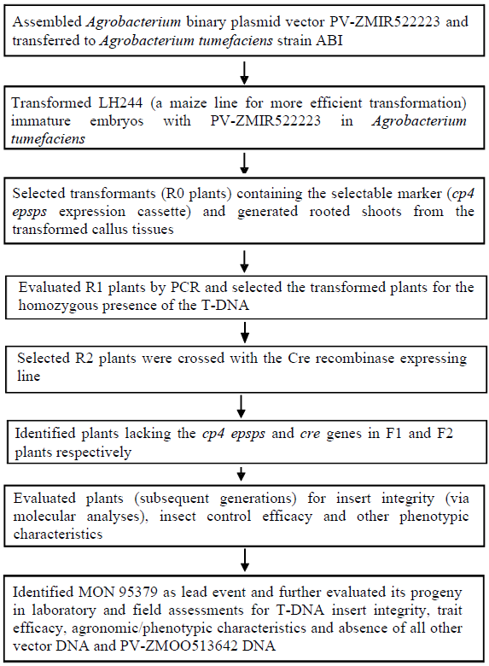

Appendix 2
PV-ZM00513642 plasmid map used to create the Cre recombinase expressing line

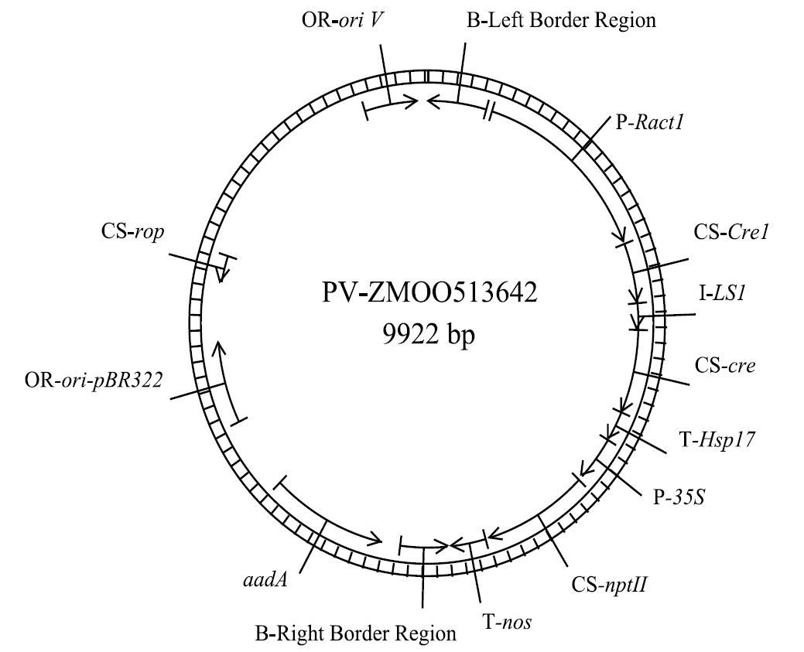

million tons
For more information please see USDA Economic Research Service: http://www.ers.usda.gov/data-products/adoption-of-genetically-engineered-crops-in-the-us.aspx
USDA Grain Report, CA14062, 2014: https://apps.fas.usda.gov/newgainapi/api/Report/DownloadReportByFileName?fileName=Agricultural%20Biotechnology%20Annual_Ottawa_Canada_7-14-2014
The NGS method was sufficiently sensitive to detect 100% of the spiked plasmid when present at 1/10th of a copy per genome equivalent or greater. Additionally, reads were mapped to a single copy of an endogenous gene and the depth of coverage for MON95379 and the controls was comprehensive.
Junction sites are comprised of the MON95379 inserted border sequences and flanking sequences in the corn genome.
Evaluation of sequences stop-to-stop codon is a more conservative approach compared to the evaluation of start-to-stop codon sequences.
http://comparedatabase.org/database/
https://www.ncbi.nlm.nih.gov/protein/
Field trial sites for testing protein expression levels were in the following US states – Iowa (two sites), Illinois, Nebraska and Ohio.
Pancreatin is a mixture of proteolytic enzymes.
The location of the five field trial sites: two sites in Iowa, and one site in Illinois, Nebraska and Ohio.

